 | Monday | Tuesday | Wednesday | Thursday | Friday
English | Please complete the lesson titled: To explore the function of apostrophes.  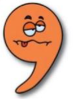  https://classroom.thenational.academy/units/t3-punctuation-level-objectives-b1b0 | Please complete the lesson titled: To explore punctuation speech first.  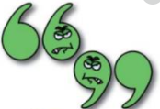  https://classroom.thenational.academy/units/t3-punctuation-level-objectives-b1b0 | Please complete the lesson titled: To revise speech punctuation.  https://classroom.thenational.academy/units/t3-punctuation-level-objectives-b1b0 | Please complete the lesson titled: To practice using simple past, present and future tense.  https://classroom.thenational.academy/units/t3-punctuation-level-objectives-b1b0 | Please complete the lesson titled: To revise simple, compound and complex sentences.  https://classroom.thenational.academy/units/t3-punctuation-level-objectives-b1b0
Mathematics | Please complete the lesson titled: Divide 1 digit by 10.  https://whiterosemaths.com/homelearning/year-4/spring-week-10-number-decimals/ | Please complete the lesson titled: Divide 2 digits by 10.  https://whiterosemaths.com/homelearning/year-4/spring-week-10-number-decimals/ | Please complete the lesson titled: Hundredths.  https://whiterosemaths.com/homelearning/year-4/spring-week-10-number-decimals/ | Please complete the lesson titled: Hundredths as decimals.  https://whiterosemaths.com/homelearning/year-4/spring-week-10-number-decimals/ | Please complete the lesson titled: Hundredths on a place value grid.  https://whiterosemaths.com/homelearning/year-4/spring-week-10-number-decimals/
Other | RE  Please complete the lesson titled: What are Hindu beliefs about karma, samsara and moksha?  https://classroom.thenational.academy/lessons/what-are-hindu-beliefs-about-karma-samsara-and-moksha-61jpat | PSHE  Please complete the lesson titled: That’s not fair.  https://classroom.thenational.academy/units/forever-friends-45e8 | PE  Watch the videos and complete the quiz to learn about dance! Can you make up your own routine or copy some of the dancers on the videos?  https://www.bbc.co.uk/bitesize/articles/z7fgvwx | SCIENCE  Please watch the video about food chains and webs.  Can you create some food chains or webs for these different habitats?  - Under the sea  - In the forest  - In the town  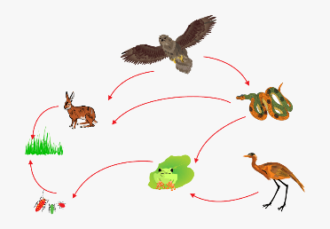  https://www.bbc.co.uk/teach/class-clips-video/science-ks2--ks3-food-chains-and-food-webs-in-animals/zn7g92p | FRENCH  Watch the videos and have a go at the activities to practice using the verbs 'avoir' and 'être'  https://www.bbc.co.uk/bitesize/articles/zg7bydm

These activities are linked to some of the work that is being completed in class this week.
If you have any questions or would like to share with me what your child has done then please feel free to email me asayer@stmarysprimary.net
Please continue to read with your child using resources online, Kent Libraries or books from home.

