 | Monday | Tuesday | Wednesday | Thursday | Friday
English | Please complete the lesson titled: To explore simple sentences.  https://classroom.thenational.academy/units/t1-sentence-level-objectives-2d3b | Please complete the lesson titled: To explore compound sentences.  https://classroom.thenational.academy/units/t1-sentence-level-objectives-2d3b | Please complete the lesson titled: To revise compound sentences.  https://classroom.thenational.academy/units/t1-sentence-level-objectives-2d3b | Please complete the lesson titled: To explore complex sentences.  https://classroom.thenational.academy/units/t1-sentence-level-objectives-2d3b | Please complete the lesson titled: To explore complex sentences (2).  https://classroom.thenational.academy/units/t1-sentence-level-objectives-2d3b
Mathematics | Please complete lesson titled: Fractions of a set of objects (1).  https://whiterosemaths.com/homelearning/year-4/spring-week-8-number-fractions/ | Please complete lesson titled: Fractions of a set of objects (2).  https://whiterosemaths.com/homelearning/year-4/spring-week-8-number-fractions/ | Please complete lesson titled: Calculate fractions of a quantity.  https://whiterosemaths.com/homelearning/year-4/spring-week-8-number-fractions/ | Please complete lesson titled: Calculate quantities.  https://whiterosemaths.com/homelearning/year-4/spring-week-8-number-fractions/ | Practise your times tables using these websites:  https://www.timestables.co.uk/  https://www.topmarks.co.uk/maths-games/7-11-years/times-tables
Other | RE  Please complete the lesson titled: How did Hinduism begin and develop as a religion?  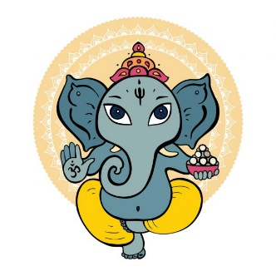  https://classroom.thenational.academy/lessons/how-did-hinduism-begin-and-develop-as-a-religion-71k38t | PSHE  Watch the video clip to remind yourself how to stay safe and happy when using a mobile phone.  Can you think of a time when you asked for help from an adult?  Are you always sensible and safe when using a mobile phone or any other device?  How could you make sure you are always safe and happy when using mobiles and other devices?  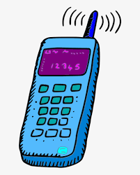  https://www.youtube.com/watch?v=Y889t-P2VwE | PE  Have a go at some Yoga with Cosmic Kids Yoga.  These exercises are great for your mental and physical health. They will help you to be mindful and to stretch your muscles.  https://www.youtube.com/user | ART  In class this term our Art lessons are going to be focused around different drawing techniques.  We are focusing on Pablo Picasso.  Watch the video and then have a go at creating your own portrait in the style of Picasso!  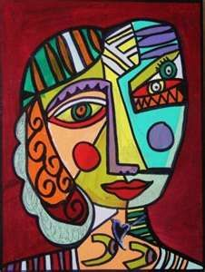  https://www.youtube.com/watch?v=wrXmE6XYbYw | SCIENCE  Please complete the lesson titled: What are organs and why do we need them?  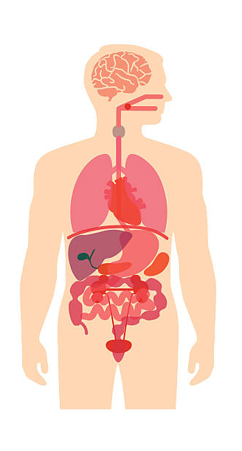  https://classroom.thenational.academy/lessons/what-are-organs-and-why-do-we-need-them-c8wk0c

These activities are linked to some of the work that is being completed in class this week.
If you have any questions or would like to share with me what your child has done then please feel free to email me asayer@stmarysprimary.net
Please continue to read with your child using resources online, Kent Libraries or books from home.

