W/C 11/01/21 | Monday |  |  |  |  | Tuesday |  |  | Wednesday |  |  |  |  | Thursday |  | Friday
9:00 - 9:10 | Daily Exercise:  Jo Wicks Work Out  https://www.youtube.com/playlist?list=PLyCLoPd4VxBvPHOpzoEk5onAEbq40g2-k |  | Daily Exercise:  Yoga  https://www.youtube.com/watch?v=nmPl3QC95r0 |  |  |  | Daily Exercise:  GoNoodle  https://family.gonoodle.com/activities/im-still-standing |  |  |  | Daily Exercise:  Jo Wicks Work Out  https://www.youtube.com/playlist?list=PLyCLoPd4VxBvPHOpzoEk5onAEbq40g2-k |  |  |  | Daily Exercise:  Yoga  https://www.youtube.com/channel/UC5uIZ2KOZZeQDQo_Gsi_qbQ
Reading:
Whilst your child is away from school it is important that they continue to take some time to read each day.
Children should either use stories that they may already have at home or use the following website where you are able to read free E-Books once you have created an account. https://www.oxfordowl.co.uk/for-home/find-a-book/library-page/?view=image&query=&type=book&age_group=Age+7-9&level=&level_select=&book_type=&series=#

Literacy  9:15- 10:00 | Starter:  What is an expanded noun phrase?  https://www.bbc.co.uk/bitesize/topics/zwwp8mn/articles/z3nfw6f  Using the link above have a go at writing expanded noun phrases.  Can you write your own?  Task:  https://www.bbc.co.uk/bitesize/articles/zfxkg7h  Discover more about how to write instructions using the following link. Please complete activity 1.  What are some of the key features of instructions?  Key Questions:  Do instructions have a title?  What information is given first?  What does ‘ingredients’ mean?  How do you know what order to do the instructions in?  What type of word does each instruction start with?  What other types of language should you include in your instructions? |  |  |  | Story: Go to https://www.bing.com/videos/search?q=how+to+wash+a+woolly+mammoth&&view=detail&mid=94C206C6ADCA5D8F4F2D94C206C6ADCA5D8F4F2D&&FORM=VDRVRV  To listen to How to Wash a Woolly Mammoth.  Task:  • Listen to the story once again.  • Draw a comic strip using resource 1A of the key parts of the story.  • Use the follow questions to help you write a sentence about each picture that you have drawn?  • Who are the characters?  • What are they doing?  • Why are they doing these actions in particular?  • Where are they? |  |  |  |  | Starter:  What are subordinating conjunctions?  https://www.bbc.co.uk/bitesize/topics/zwwp8mn/articles/zqk37p3  Using the link above have a go at using subordinating conjunctions.  Can you write your own?  Task:  Using your learning from yesterday have a go at writing your own instructions for how to wash a woolly mammoth.  Remember some of the key information about instructions:  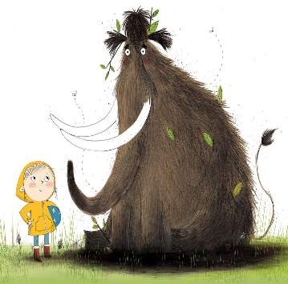  • They include imperative verbs (bossy). (Scrub, Gather, Rinse, Wash)  • They tell us what tools we will need and how to use them.  • The method tells us what to do in chronological order.  • Every sentence begins with a time conjunction. (First, Then, Next) |  |  | Starter:  What types of information do we need to include in a character description?  Use the link below to find out more about writing character descriptions.  https://www.bbc.co.uk/bitesize/articles/zs8cvwx  Practice writing a description by completing task 1 (found on through the learning link)  Task:  Using the image below. Can you write some descriptive sentences about the wooly mammoth? |  |  |  | Starter:  Follow the link below to complete learning on word classes.  https://classroom.thenational.academy/lessons/to-explore-word-classes-61gp6t  Task:  - Watch the video:  - https://vimeo.com/91642206  - In the story we meet three characters: rock, paper and scissors.  - How would you describe each characters personality and appearance?  - What do their actions tell you about the kind of person they are?  - Write at least two sentences about each characters using lots of adjectives!  - You could even draw a picture!  - Extension:  - Pick on character, write a setting description about their home.
Break

10:00 - 10:30
Mathematics  10:30 - 11:15 |  | For each day I have provided a link to a video lesson, every lesson includes suggested activities the children could carry out.  I have also included additional activities that your child can complete as an extension which is based on our prior learning this school year.
Starter: Practice your times tables. Please focus on your 3,4 and 8 times tables.
Here are some links which will allow you to practice your times tables.
Times Tables Songs:
The 3 times table
https://www.bbc.co.uk/bitesize/articles/zk6vn9q

The 4 times table
https://www.bbc.co.uk/bitesize/articles/zfsqkty
The 8 times table
https://www.bbc.co.uk/bitesize/articles/zrrbsk7

Times Tables Games:
https://www.topmarks.co.uk/maths-games/7-11-years/times-tables
https://www.timestables.co.uk/games/

 |  | Task:  Lesson 1:  Divide 2-digits by 1-digit (1)  Spr3.2.3 - Divide 2-digits by 1 digit (1) on Vimeo  Click on the link above, this will take you to our learning video for today. Remember to pause the video each time to have a go at answering the questions.  Please record your answers on a piece of paper.  Extension:  Recap your place value knowledge with the following link.  Complete the activities and the quiz on the webpage.  https://www.bbc.co.uk/bitesize/articles/z793p4j |  | Task:  Lesson 2:  Divide 2-digits by 1-digit (2)  Spr3.2.4 - Divide 2-digits by 1 digit (2) on Vimeo  Click on the link above, this will take you to our learning video for today. Remember to pause the video each time to have a go at answering the questions.  Please record your answers on a piece of paper.  Extension:  Have a go at the Place Value Workbook.  https://wrm-13b48.kxcdn.com/wp-content/uploads/2020/07/Y3-HL-Autumn-Block-1-Place-value-2020.pdf  Please note: This workbook is taken from White Rose and as such a safe link however, your computer may ask you if you are sure if it is safe, to open the workbook please click yes. |  |  |  | Task:  Lesson 3:  Dividing 100  https://vimeo.com/489848691  Extension:  Continue with the place value booklet from the previous day. |  |  |  | Task:  Lesson 4:  Divide with remainders  https://vimeo.com/492449125  Extension:  Follow the link below to play some place value games.  https://www.topmarks.co.uk/maths-games/7-11-years/place-value |  |  |  | Task:  Lesson 5:  Divide 2-digits by 1-digit. (3)  https://vimeo.com/494126561  Extension:  Follow the link below to play some place value games.  https://www.topmarks.co.uk/maths-games/7-11-years/place-value
Lunch Break

11:45 - 13:00
Afternoon Activity  13:00 - 14:30 |  | History:  Follow the link below to learn more about the different animals that lived in prehistoric Britain.  https://classroom.thenational.academy/lessons/which-animals-lived-in-prehistoric-britain-cgw6cd |  | RE:  Follow the link bellow to learn about the holy trinity.  https://classroom.thenational.academy/lessons/what-is-the-holy-trinity-cthk6c |  |  |  | Science:  Follow the link below to learn about metamorphic rock.  https://classroom.thenational.academy/lessons/how-is-metamorphic-rock-formed-c4uk8d |  |  |  | Computing:  Try out one of the Hour of Code activities from |Code.org - https://code.org/hourofcode/overview  Each tutorial gives step by step explanation about what to do. |  |  |  | Art:  Using the PowerPoint from last week, which can be found on the school website. Continue with lesson 2.  In this lesson thik more about how we can draw objects in different ways.  Experiment with different pencils or pens.  What happens when you press down hard with a pencil?
Reflection  2:30-3:00 | Monday  How could you help at home today? | Tuesday  Choose a mindfulness activity to complete by clicking the image below. | Wednesday  Complete one of the activities from the PSHE Poster by clicking the image below. | Thursday  Watch news round  https://www.bbc.co.uk/newsround  What important events have happened this week? | Friday  What do you feel proud of achieving this week?  What is something you would like to work on next week?

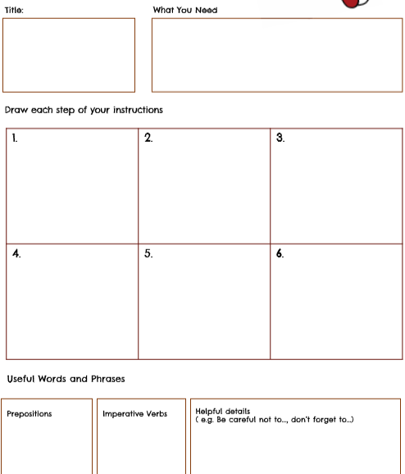

1A.

