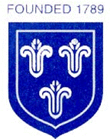
St Mary’s Church of England Primary School
Home Learning
Class 4 | Monday  25.1.2021 | Tuesday  26.1.2021 | Wednesday  27.1.2021 | Thursday  28.1.2021 | Friday  29.1.2021
Reading | Read every day to enhance your reading skills. Remember, reading does not just have to be books, it could be comics, online or newspapers. 10-15 minutes minimum every day.  Use this link to access Roald Dahl ‘The Giraffe, the Pelly and Me ’. You can choose to read some of the book yourself on the screen or listen to the book being read to you. Maybe you could do a bit of both! Enjoy!  https://www.youtube.com/watch?v=wL3NuLOsJHs
Spellings | learn, length, library, material, medicine, mention, minute.
 | Write out the spellings in a list. Have a good look at them. What do you notice? Are there any patterns that you could use to help you remember the words?  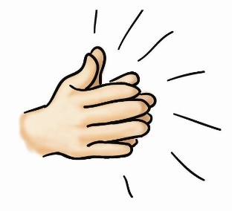  Say each word out loud and clap each letter. | Write your spellings in steps, starting with the first letter and then adding the next letter each time.  Eg: Learn  L  LE  LEA  LEAR  LEARN | Remember the spelling scribbles we use in school? You can create your own. All you need to do is draw a big scribble on some paper. Make sure you create lots of ‘bubbles’ that you can fill with your spellings.  Once you have created your scribble, fill it with your spellings (this is a great opportunity to practise your handwriting too!) | Write your spellings in different colours and fonts.  Can you use a font that you’ve never used before?  Can you create some patterns on your spellings?  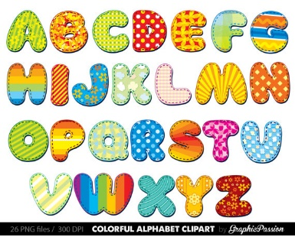  Can you write your spellings backwards? | Time for a spelling test!  Make sure you have a plain piece of paper. Ask someone at home to read out your spellings one by one. As they read them, write them down on your piece of paper.  Once you have finished, ask someone to check your spellings.  How many did you get correct? Please email me to let me know your score
Punctuation & Grammar | Please complete lesson 1: ‘To explore simple and compound sentences’.  https://classroom.thenational.academy/units/t1-sentence-level-objectives-aab1 | Please complete lesson 2: ‘To revise our understanding of simple and compound sentences’.  https://classroom.thenational.academy/units/t1-sentence-level-objectives-aab1 | Please complete lesson 3: ‘To explore complex sentences’.  https://classroom.thenational.academy/units/t1-sentence-level-objectives-aab1 | Please complete lesson 4: ‘To develop understanding of complex sentences’.  https://classroom.thenational.academy/units/t1-sentence-level-objectives-aab1 | Please complete lesson 5: ‘To develop our understanding of simple, compound and complex sentences’.  https://classroom.thenational.academy/units/t1-sentence-level-objectives-aab1
Literacy  Please email me any work completed as I really want to see how you have got on. | In today’s Literacy lesson you will be exploring the key characters from ‘The Borrowers’.  Please complete lesson 1: ‘To develop an understanding of key characters from ‘The Borrowers’.  https://classroom.thenational.academy/units/the-borrowers-narrative-writing-c96c | In today’s Literacy lesson you will be focusing on suffixes. I wonder how many you can include in your writing in the future?  Please complete lesson 2: ‘To investigate suffixes –ary/-ery’.  https://classroom.thenational.academy/units/the-borrowers-narrative-writing-c96c | In today’s Literacy lesson you will be thinking about your previous learning about word class and putting this into practise.  Please complete lesson 3: ‘To revise our knowledge of word class’.  https://classroom.thenational.academy/units/the-borrowers-narrative-writing-c96c | In today’s Literacy lesson you will be thinking about character descriptions. We have completed lots of this in class, so you should be able to remember and think of some great vocabulary to describe characters (remember to use adjectives and similes!)  Please complete lesson 4: ‘To generate vocabulary for character description’.  https://classroom.thenational.academy/units/the-borrowers-narrative-writing-c96c | In today’s Literacy lesson you will be thinking about some different vocabulary to describe large objects. How creative can you be?  Please complete lesson 5: To develop a rich understanding of words associated with large objects’.  https://classroom.thenational.academy/units/the-borrowers-narrative-writing-c96c
Mathematics | In today’s maths lesson you are going to be learning how to divide 2-digits by 1-digit using different methods.  Please complete lesson 1: ‘Divide 2-digits by 1-digit (3)’.  Please do not worry about printing any worksheets or resources. Completing the work on paper will be great  https://whiterosemaths.com/homelearning/year-4/spring-week-3-number-multiplication-and-division/ | In today’s maths lesson you are going to be reinforcing your knowledge of how to divide 2-digits by 1-digit.  Please complete lesson 2: ‘Divide 2-digits by 1-digit (2)’.  Please do not worry about printing any worksheets or resources. Completing the work on paper will be great  https://whiterosemaths.com/homelearning/year-4/spring-week-3-number-multiplication-and-division/  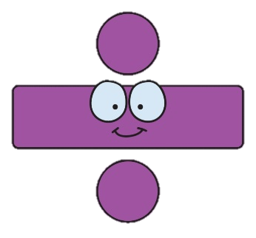 | In today’s maths lesson you are going to be learning how to divide 3-digits by 1-digit using different methods.  Please complete lesson 3: ‘Divide 3-digits by 1-digit’.  Please do not worry about printing any worksheets or resources. Completing the work on paper will be great  https://whiterosemaths.com/homelearning/year-4/spring-week-3-number-multiplication-and-division/  *Challenge: Click on the PDF document below to access today’s challenge question. | In today’s maths lesson you are going to be learning how to answer correspondence problems. These involve looking at different combinations and possibilities and using your multiplication skills to help you work out the answers.  Please complete lesson 4: ‘Correspondence Problems’.  Please do not worry about printing any worksheets or resources. Completing the work on paper will be great  https://whiterosemaths.com/homelearning/year-4/spring-week-3-number-multiplication-and-division/  *Challenge: Click on the PDF document below to access today’s challenge question. | This website comes from BBC Bitesize and has some great activities for you to have a go at!  Will you complete some tricky number puzzles?  Or maybe you will practise and learn some new skills with some maths games?  There are also some great worksheet activities that you can complete online to test your amazing maths knowledge!  https://www.mathsisfun.com/  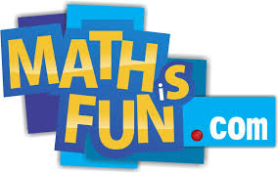
Times Tables | Practise your 6 times table with this song.  https://www.youtube.com/watch?v=e7rYbk9PNuM | Practise your 7 times table with this song.  https://www.youtube.com/watch?v=LcSwgZ48ph8 | Practise your 9 times table with this song.  https://www.youtube.com/watch?v=H3BGwzdLDBY | Which times tables will you practise today? https://www.timestables.co.uk/ | Have fun practising your times tables! Can you challenge yourself?  https://mathsframe.co.uk/en/resources/resource/318/Tommys-Trek-Times-Tables
Other Subjects | RE  This is your second session about Gospel.  Read through the information and answer the questions based on your own thoughts.  Double click the PDF document below to access today’s RE lesson.  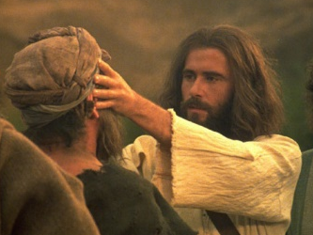 | SCIENCE  Complete the lesson to find out about The water cycle. You should be able to remember some parts of the cycle from our last topic, so use this lesson as a reminder and to further your knowledge. Let me know how you get on.  https://www.bbc.co.uk/bitesize/topics/zkgg87h/articles/z3wpp39  Here are some other great videos about our topic ‘States of Matter’ that might spark your interest!  https://www.youtube.com/watch?v=DE3LCPfP8N8  https://www.youtube.com/watch?v=BitWextjtzM  https://www.youtube.com/watch?v=bHlP1lRc0Tg  https://www.youtube.com/watch?v=cHIHbJ7ob-4 | PSHE  This lesson is about Tolerance and Respect Your aim is to describe a diverse society and talk about why it is important.  Double click the PDF document below to access today’s PSHE lesson. | ART  For today’s Art lesson I have found a fun idea that is similar to the spelling scribbles that we create at school.  https://www.youtube.com/watch?v=0fPW1Xhi2Mk  This video gives you an example of how to create ‘Scribble Creatures’.  This activity will be great to help you relax and to get your imagination running wild!  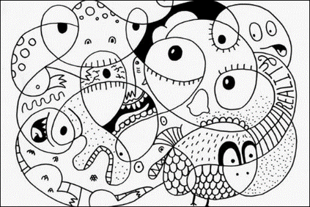  Please send me some photos of what you create, I can’t wait to see! | HISTORY/GEOGRAPHY  In this lesson you are going to learn about how the Roman Empire became so powerful.  After watching the video and completing the tasks, have a go at the final quiz to test your knowledge.  https://classroom.thenational.academy/lessons/how-did-the-roman-empire-become-so-powerful-74u62t  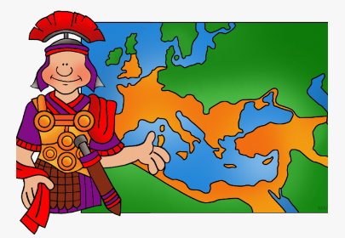
 | MUSIC  After seeing how much fun some of you had with the body percussion lesson a few weeks ago, I came across another one! I hope you enjoy it!  https://www.youtube.com/watch?v=QOh1P1ZcTaU  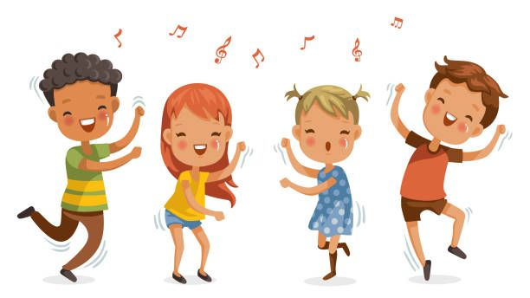 | HANDWRITING  In today’s handwriting lesson, I would like you to watch the video clip (I hope it makes you laugh a little). Once you have watched the video I would like you to write in no more than 100 words what happened in the video from start to finish.  However, this must be done in your best, neatest joined up writing!  https://www.literacyshed.com/marshmallows.html | COMPUTING  In today’s computing lesson, I would like to remind you about internet safety. It is always important to think about how we use the internet and the things we can do to stay safe.  Here is a video of a book read aloud about internet safety. Hopefully it will just give you a little reminder about staying safe online.  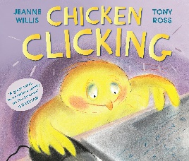  https://www.youtube.com/watch?v=sMqptWPBzMs | HANDWRITING  In today’s handwriting lesson, I would like you to write what your favourite part of the marshmallow video is. Which part made you laugh the most?  Remember, this must be done in your best, neatest joined up writing!  Please send me a picture so I can see how you got on.  Here is the video again if you would like to re-watch it.  https://www.literacyshed.com/marshmallows.html | FRENCH  In this lesson you are going to be learning about Animals and pets.  We have had a go at some of this in the classroom so some of you might know some of the words already!  Read and listen to the sentences and then try to create your own.  Can you say them to someone else in your house?  Can you write your sentences down and draw pictures to help you remember what each sentence says?  https://www.bbc.co.uk/bitesize/topics/zjcbrj6/articles/z78wjhv
Thinking Time | Gratitude Tree  Have a look at the gratitude tree information at the end of this document.  This might be a nice task to think about and complete over this week, or even over the next few weeks.  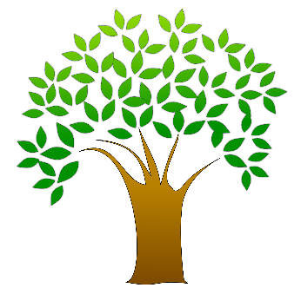 | Have a go at some yoga with Cosmic Kids Yoga sessions!  There are lots to choose from on their YouTube channel from Sonic the Hedgehog to Harry Potter!  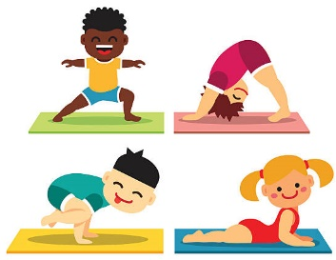  https://www.youtube.com/results?sp=mAEB&search_query=cosmic+kids+yoga | How is your week going so far?  Think about the positives…  Think about the things that could have gone better?  How are you going to make sure the rest of your week is happy and positive?  Have you managed to add some leaves to your Gratitude Tree?  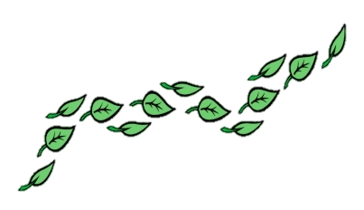 | Have a go at this muscle relaxation video. It is important to take care of your whole body and this video will help you to relax all your muscles.  https://www.youtube.com/watch?v=cDKyRpW-Yuc  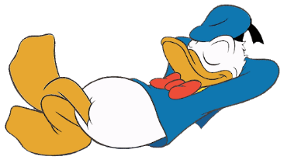 | How has your week been?  What are you proud of this week?  What fun things are you looking forward to this weekend?
Exercise and Break times | Get yourself moving and try to complete a Joe Wicks or Go Noodle workout once a day.  https://family.gonoodle.com/  https://www.youtube.com/watch?v=d3LPrhI0v-w  Chill out and relax by trying one of these children’s yoga videos.  https://www.youtube.com/user/CosmicKidsYoga | Get yourself moving and try to complete a Joe Wicks or Go Noodle workout once a day.  https://family.gonoodle.com/  https://www.youtube.com/watch?v=d3LPrhI0v-w  Chill out and relax by trying one of these children’s yoga videos.  https://www.youtube.com/user/CosmicKidsYoga | Get yourself moving and try to complete a Joe Wicks or Go Noodle workout once a day.  https://family.gonoodle.com/  https://www.youtube.com/watch?v=d3LPrhI0v-w  Chill out and relax by trying one of these children’s yoga videos.  https://www.youtube.com/user/CosmicKidsYoga | Get yourself moving and try to complete a Joe Wicks or Go Noodle workout once a day.  https://family.gonoodle.com/  https://www.youtube.com/watch?v=d3LPrhI0v-w  Chill out and relax by trying one of these children’s yoga videos.  https://www.youtube.com/user/CosmicKidsYoga | Get yourself moving and try to complete a Joe Wicks or Go Noodle workout once a day.  https://family.gonoodle.com/  https://www.youtube.com/watch?v=d3LPrhI0v-w  Chill out and relax by trying one of these children’s yoga videos.  https://www.youtube.com/user/CosmicKidsYoga

Please email me daily to let me know how you are getting on with the activities I have set you, if you could send me photographs of what you have been doing that would be great - I love to see your learning!
asayer@stmarysprimary.net

Mindfulness: The Gratitude Tree:
At the moment things are different, but we need to focus on the positives we do have in difficult time and there are lots of things to grateful for even now.

Can you complete the gratitude meditation (link below)? This will help you think about all the things you might be grateful for: This is something you may not have done many times before – don’t worry if you can’t manage it in one go! Come back and finish it later.
https://insighttimer.com/thehappyhabit/guided-meditations/growing-gratitude-meditation-for-kids
We are going to make a gratitude tree: there are many ways you can do this – draw, cut one out, roll up some newspaper, or collect actual sticks if you are able to – be creative! Here are some examples:
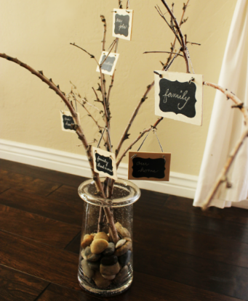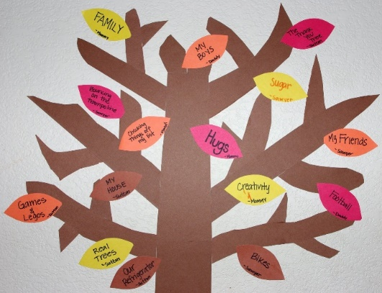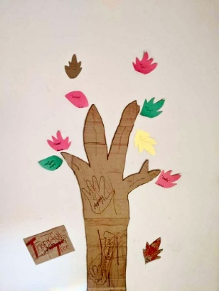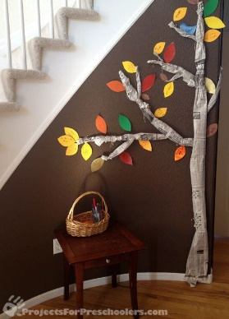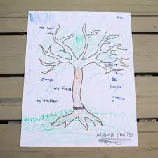
Each day I want you to think of something that you are grateful for – from people around you, your favourite food or toy, the weather … anything! Each day I want to write down the things you are grateful for and add it to your tree, so when you need to you can look at them and remember the good things. You could write your ideas on leaf shaped pieces of paper – or sticky notes – or anything you have to hand! Then send them into your teachers and we can share them on the school Facebook page to make us all smile!

There are also some ideas for things you could be grateful for in this short song by Hap Palmer: https://youtu.be/TKl8BuVWnUA

