 | Monday | Tuesday | Wednesday | Thursday | Friday
English | Lesson 1:  Oliver and The Seawigs: Chapter 5 - YouTube  Click on the link above then answer the questions below. Please write in full sentences.  Define ‘abandoned  How do we know Oliver’s parents were in trouble?  How do you think Oliver felt when the Thurlstone turned and moved away?  Predict what they will do to rescue Oliver’s mum and dad.  What dangled from the branches of Thurlstone?  What did the seaweeds have on the top of them?  Think of one word to describe Stacey de Lacey. Then, explain why you chose this word | Lesson 2:  In today’s lesson we will be exploring the character of Stacey de Lacey.  Let’s think about the characters of Stacey de Lacey and his Sea Monkeys…what are they like? How do they behave? How would you describe them? Add your ideas around the images of Stacey de Lacey. I would like you to pick at least 4 adjectives to describe him.  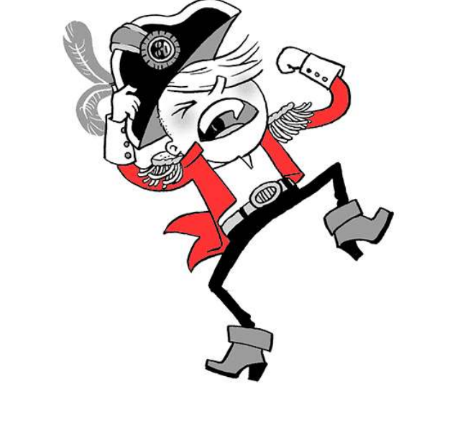 | Lesson 3:  In today’s lesson I would like you to write some questions that you would like to ask Oliver after the events of Chapter 5.  Remember use our key question words to help you.  Who?  What?  Where?  When?  Why? | Lesson 4:  In today’s lesson I would like you to add speech marks to the following sentences. These sentences may also be missing other punctuation.  1. it’s got a face he said.  2. what’s a Seawig he asked.  3. i bet Thrumcap wins this time said the island.  4. you need a name said Oliver.  5. excuse me said Mr Culpepper  Extension:  Imagine you are Oliver, write a conversation between you and Stacey de Lacey convincing him to give you your parents back. Remember to use your speech marks. | Lesson 5:  In today’s SPAG lesson we are going to be recapping our understanding of ‘ed’ and exploring apostrophes for possession. Please click on each of the links below and engage with the lesson.  To investigate suffixes: Past and present tense (thenational.academy)  To introduce apostrophes for singular possession (thenational.academy)
Mathematics | Lesson 1:  Sum3.9.1 - Measure mass activity on Vimeo  In this lesson we are going to be measuring mass.  Please double click on the link above to access today’s lesson. You will need a pencil and paper to record your answers on. | Lesson 2:  Sum3.9.2 - Compare mass on Vimeo  In this lesson we are going to be comparing mass.  Please double click on the link above to access today’s lesson. You will need a pencil and paper to record your answers on. | Lesson 3:  Sum3.9.3 - Measure mass (1) on Vimeo  In this lesson we are going to be measuring mass.  Please double click on the link above to access today’s lesson. You will need a pencil and paper to record your answers on. | Lesson 4:  Sum3.9.4 - Measure mass (2) on Vimeo  In this lesson we are going to be continuing to measure mass.  Please double click on the link above to access today’s lesson. You will need a pencil and paper to record your answers on. | Lesson 5:  Sum3.9.5 - Compare mass on Vimeo  In this lesson we are going to be comparing mass.  Please double click on the link above to access today’s lesson. You will need a pencil and paper to record your answers on.
Other | RE:  Where and how do Sikhs worship? (thenational.academy)  In today’s lesson we will be exploring how Sikhs worship. Click on the link above and following along with the video. Please complete any activities direct by the teacher in the video. | Geography:  Please double click on the PowerPoint above to follow along with today’s lesson. Using the PowerPoint to help you create a poster containing a drawing of the Great Barrier Reef and at least 4 facts about it. For example what animals can be found there? | French  Animals and Pets - KS2 French - BBC Bitesize - BBC Bitesize  In today’s lesson we will be applying our knowledge of pets in French to say a sentence about a pet that we have at home (or a pet we would like to have). Click on the link above and scroll through the webpage. Make sure to click on any sound buttons and copy the French aloud. | Science:  What does your skeleton do? - BBC Bitesize  In today’s lesson we are going to be learning more about the skeleton. Please double click on the PowerPoint above to follow along and complete any activities given to you within the PowerPoint. | Art:  How To Draw A Realistic Sea Turtle - YouTube  Double click on the video above to learn how to draw a Sea turtle using step by step methods.

