 | Monday | Tuesday | Wednesday | Thursday | Friday
English | Please complete the lesson titled: To explore a theme.  https://classroom.thenational.academy/units/king-of-the-sky-by-nicola-davies-56dc | Please complete the lesson titled: To engage with a text.  https://classroom.thenational.academy/units/king-of-the-sky-by-nicola-davies-56dc | Please complete the lesson titled: To analyse a character.  https://classroom.thenational.academy/units/king-of-the-sky-by-nicola-davies-56dc | Please complete the lesson titled: To explore figurative language.  https://classroom.thenational.academy/units/king-of-the-sky-by-nicola-davies-56dc | Please complete the lesson titled: To generate and explore themes.  https://classroom.thenational.academy/units/king-of-the-sky-by-nicola-davies-56dc
Mathematics | Please complete the lesson titled: Turns and Angles.  https://whiterosemaths.com/homelearning/year-4/summer-week-8-geometry-properties-of-shape/ | Please complete the lesson titled: Right Angles in Shapes.  https://whiterosemaths.com/homelearning/year-4/summer-week-8-geometry-properties-of-shape/ | Please complete the lesson titled: Compare Angles.  https://whiterosemaths.com/homelearning/year-4/summer-week-8-geometry-properties-of-shape/ | Please complete the lesson titled: Identify Angles.  https://whiterosemaths.com/homelearning/year-4/summer-week-8-geometry-properties-of-shape/ | Please complete the lesson titled: Compare and Order Angles.  https://whiterosemaths.com/homelearning/year-4/summer-week-8-geometry-properties-of-shape/
Other | RE  Please complete the lesson titled: What is a human?  https://classroom.thenational.academy/units/humanism-d630   | COMPUTING  Practise your times table speed test, how fast can you go?  https://www.timestables.co.uk/speed-test/  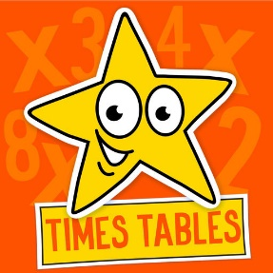 | PE  Get yourself moving and try to complete a Joe Wicks or Go Noodle workout once a day.  https://family.gonoodle.com/    https://www.youtube.com/watch?v=d3LPrhI0v-w | FRENCH  Please complete the lesson titled: Saying that it is or isn’t a certain pet.  https://classroom.thenational.academy/lessons/saying-that-it-is-or-isnt-a-certain-pet-c4v6ct   | SCIENCE  Please complete the lesson titled: How are different sounds produced?  https://classroom.thenational.academy/lessons/how-are-different-sounds-produced-6nj3et  

These activities are linked to the work that is being completed in class this week.
If you have any questions or would like to share with me what your child has done then please feel free to email me asayer@stmarysprimary.net
Please continue to read with your child using resources online, Kent Libraries or books from home.

