 | Monday | Tuesday | Wednesday | Thursday | Friday
English | Lesson 1:  Reading  Please click on the link below to listen to chapter 2.  Oliver and The Seawigs: Chapter 2 - YouTube  (Pause at 11.25)  After pausing at 11.25 look at the picture of Iris. Using the picture, write a range of words that describe Iris’ appearance and main character traits.  Extension: Draw a picture of Iris using the description that you have written about her. | Lesson 2:  Chapter 3: Oliver and The Seawigs - YouTube  Listen to Chapter 3, paying careful attention to how the Seawigs are described.  What would you add to a seawig to win the seawig contest?  Using the sheet below for guidance design your own seawig.  seawigs_styleaseawig1_300.tif (jabberworks.co.uk) | Lesson 3:  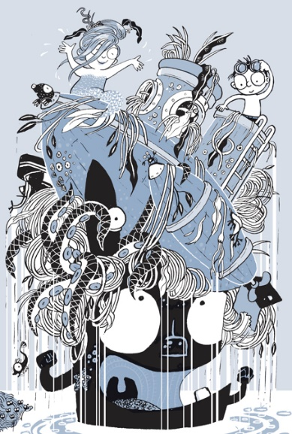  Meet Cliff the seawig. For today’s lesson I would like you to write a descriptive paragraph about what you can see on top of Cliff’s head. Remember to use a range of exciting adjectives. | Lesson 4:  Listen to/ read along with Chapter 4  Oliver and The Seawigs: Chapter 4 - YouTube  Oliver and Iris have just discovered the water mole. Use the picture below to continue this sentence:  You can find a more detailed image at the bottom of the document.  As Oliver sawn down towards the seabed he felt astonished to see…  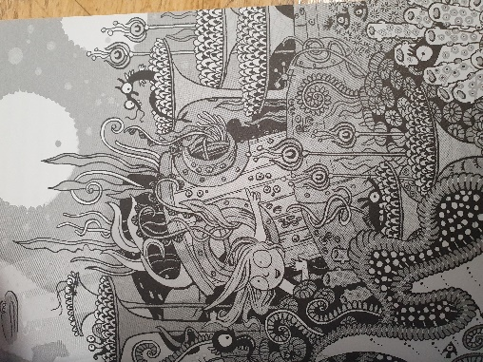 | Lesson 5:  Based on Chapter 4 answer the following questions. Please write in full sentences.  Define ‘nimble’.  What does it mean if something is ‘ancient’?  Why did Oliver’s heart ‘hammer’ and his eyes ‘bulge’?  Predict where they will go next after this chapter.  Explain why the author calls it the ‘sarcastic sea.  Why do some ‘Rambling Isles’ stop moving?  How does the mermaid know where the submarine is?
Mathematics | Lesson 1:  Sum3.8.1 - Parallel and perpendicular on Vimeo  In this lesson we are going to be exploring parallel and perpendicular lines.  Please double click on the link above to access today’s lesson. You will need a pencil and paper to record your answers on. | Lesson 2:  Sum3.8.2 - Recognise and describe 2-D shapes on Vimeo  In this lesson we are going to describing 2-D shapes.  Please double click on the link above to access today’s lesson. You will need a pencil and paper to record your answers on. | Lesson 3:  Sum3.8.3 - Recognise and describe 3-D shapes on Vimeo  In this lesson we are going to be exploring 3-D shapes.  Please double click on the link above to access today’s lesson. You will need a pencil and paper to record your answers on. | Lesson 4:  Sum3.8.4 - Make 3-D shapes on Vimeo  In this lesson we are going to be continuing to explore 3-D shapes.  Please double click on the link above to access today’s lesson. You will need a pencil and paper to record your answers on. | Lesson 5:  To draw 2-D shapes based on their properties (thenational.academy)  In this lesson we are going to be drawing 2-D shapes based on their properties.  Please double click on the link above to access today’s lesson. You will need a pencil and paper to record your answers on.
Other | RE:  How do Sikhs express their faith today? (thenational.academy)  In today’s lesson we will be exploring how Sikhs express their faith today. Click on the link above and following along with the video. Please complete any activities direct by the teacher in the video. | Geography:  Please double click on the PowerPoint above to follow along with today’s lesson. Using the PowerPoint to help you create a poster containing a drawing of Uluru as well as at least 4 facts about the rock itself. | French  In today’s lesson we will be recapping our colours in French. Click on the link above and follow the PowerPoint. | Science:  What are the key parts of a healthy diet? (thenational.academy)  In today’s lesson we are going to be learning more about the different types of Nutrition. Please double click on the PowerPoint above to follow along and complete any activities given to you within the PowerPoint. | Art:  How To Draw A Coral Reef - Bing video  Double click on the video above to learn how to draw a Coral reef using step by step methods.



