 | Monday | Tuesday | Wednesday | Thursday | Friday
English | Please complete the lesson titled: To engage with the text.  https://classroom.thenational.academy/units/walter-tulls-scrapbook-by-michaela-morgan-1e50 | Please complete the lesson titled: To read about Walter Tull’s family and childhood.  https://classroom.thenational.academy/units/walter-tulls-scrapbook-by-michaela-morgan-1e50 | Please complete the lesson titled: To read about Walter Tull’s career in football.  https://classroom.thenational.academy/units/walter-tulls-scrapbook-by-michaela-morgan-1e50 | Please complete the lesson titled: To read about Walter Tull’s career in the army.  https://classroom.thenational.academy/units/walter-tulls-scrapbook-by-michaela-morgan-1e50 | Please complete the lesson titled: To reflect upon the text we have read.  https://classroom.thenational.academy/units/walter-tulls-scrapbook-by-michaela-morgan-1e50
Mathematics | Please complete the lesson titled: Interpret Charts.  https://whiterosemaths.com/homelearning/year-4/summer-week-7-statistics/ | Please complete the lesson titled: Comparison, sum and difference.  https://whiterosemaths.com/homelearning/year-4/summer-week-7-statistics/ | Please complete the lesson titled: Introducing Line graphs. https://whiterosemaths.com/homelearning/year-4/summer-week-7-statistics/ | Please complete the lesson titled: Line graphs.  https://whiterosemaths.com/homelearning/year-4/summer-week-7-statistics/ | Take this time to practice your times tables using the following websites:  https://www.timestables.co.uk/  https://mathsframe.co.uk/en/resources/resource/318/Tommys-Trek-Times-Tables  https://www.topmarks.co.uk/maths-games/7-11-years/times-tables
Other | RE  Please complete the lesson titled: How do Hindus express their faith today?  https://classroom.thenational.academy/lessons/how-do-hindus-express-their-faith-today-c8tk8c  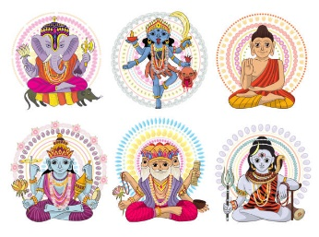 | PSHE  Please complete the lesson titled: Life is all about balance.  https://classroom.thenational.academy/units/eat-well-live-well-7109   | PE  Get yourself moving and try to complete a Joe Wicks or Go Noodle workout once a day.  https://family.gonoodle.com/    https://www.youtube.com/watch?v=d3LPrhI0v-w | FRENCH  Please complete the lesson titled: Saying the name of six pets.  What pets do you have or would you like to have? Can you say the names of these in French?  https://classroom.thenational.academy/units/quest-ce-que-cest-dfa6   | SCIENCE  Please complete the lesson titled: What is sound?  Can you create a poster about what you have learnt today?  https://classroom.thenational.academy/lessons/what-is-sound-chh30r  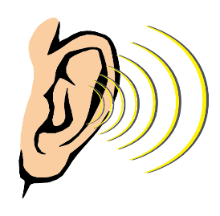

These activities are linked to some of the work that is being completed in class this week.
If you have any questions or would like to share with me what your child has done then please feel free to email me asayer@stmarysprimary.net
Please continue to read with your child using resources online, Kent Libraries or books from home.

