 | Monday | Tuesday | Wednesday | Thursday | Friday
English | Please complete the lesson titled: To engage with the text.  https://classroom.thenational.academy/units/theres-a-boy-in-the-girls-bathroom-by-louis-sachar-f0f8 | Please complete the lesson titled: To analyse a character (Bradley).  https://classroom.thenational.academy/units/theres-a-boy-in-the-girls-bathroom-by-louis-sachar-f0f8 | Please complete the lesson titled: To analyse a character (Jeff).  https://classroom.thenational.academy/units/theres-a-boy-in-the-girls-bathroom-by-louis-sachar-f0f8 | Please complete the lesson titled: To explore Bradley further.  https://classroom.thenational.academy/units/theres-a-boy-in-the-girls-bathroom-by-louis-sachar-f0f8 | Please complete the lesson titled: To explore a theme.  https://classroom.thenational.academy/units/theres-a-boy-in-the-girls-bathroom-by-louis-sachar-f0f8
Mathematics | Please complete the lesson titled: Divide 1 or 2 digits by 100.  https://whiterosemaths.com/homelearning/year-4/spring-week-11-number-decimals/ | Please complete the lesson titled: Make a whole.  https://whiterosemaths.com/homelearning/year-4/summer-week-1-number-decimals/ | Please complete the lesson titled: Write decimals activity.  https://whiterosemaths.com/homelearning/year-4/summer-week-1-number-decimals/ | Please complete the lesson titled: Write decimals.  https://whiterosemaths.com/homelearning/year-4/summer-week-1-number-decimals/ | Please complete the lesson titled: Compare decimals.  https://whiterosemaths.com/homelearning/year-4/summer-week-1-number-decimals/

Other | RE  Please complete the lesson titled: Who is Brahman to Hindus?  Can you write down or tell someone at home why Brahman is important to Hindus?    https://classroom.thenational.academy/lessons/who-is-brahman-to-hindus-65k30d | PSHE  Please complete the lesson titled: Forever Friends.  What makes a good friend?    https://classroom.thenational.academy/units/forever-friends-45e8 | PE  Below is the YouTube channel for Cosmic Yoga Kids! There are lots of videos for you to choose from!  Did you know Yoga is great for relaxing your mind and body? What else can you do at home to relax and feel peaceful?  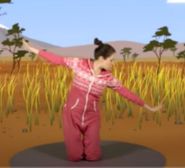  https://www.youtube.com/user/cosmickidsyoga | SCIENCE  Have a go at these interactive activities to learn about the parts of a food chain.  Can you tell someone at home what a producer is?  Can you tell someone what a consumer is?  Where does the predator come in a food chain?  https://www.bbc.co.uk/bitesize/topics/zbnnb9q  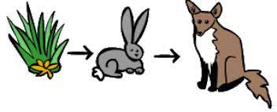 | FRENCH  Use the interactive activities and videos to learn about the weather and seasons in French. Can you say two sentences about today’s weather to someone at home?  https://www.bbc.co.uk/bitesize/topics/zjcbrj6/articles/zcskbqt  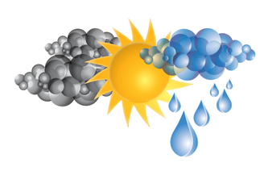

These activities are linked to some of the work that is being completed in class this week.
If you have any questions or would like to share with me what your child has done then please feel free to email me asayer@stmarysprimary.net
Please continue to read with your child using resources online, Kent Libraries or books from home.

