 | Monday | Tuesday | Wednesday | Thursday | Friday
English | Complete lesson 1: To engage with a text.  https://classroom.thenational.academy/units/hansel-and-gretel-by-anthony-browne-e2f3 | Complete lesson 2: To answer questions on the text.  https://classroom.thenational.academy/units/hansel-and-gretel-by-anthony-browne-e2f3 | Complete lesson 3: To answer questions on the text (2).  https://classroom.thenational.academy/units/hansel-and-gretel-by-anthony-browne-e2f3 | Complete lesson 4: To analyse a character.  https://classroom.thenational.academy/units/hansel-and-gretel-by-anthony-browne-e2f3 | Complete lesson 5: To explore genre.  https://classroom.thenational.academy/units/hansel-and-gretel-by-anthony-browne-e2f3
Mathematics | Please complete lesson: Subtract Fractions.  https://whiterosemaths.com/homelearning/year-4/spring-week-7-number-fractions/ | Please complete lesson: Subtract Two Fractions.  https://whiterosemaths.com/homelearning/year-4/spring-week-7-number-fractions/ | Please complete lesson: Subtract from Whole Amounts.  https://whiterosemaths.com/homelearning/year-4/spring-week-7-number-fractions/ | Please complete lesson: Fractions of a Set of Objects (1).  https://whiterosemaths.com/homelearning/year-4/spring-week-8-number-fractions/ | Please complete lesson: Fractions of a Set of Objects (2).  https://whiterosemaths.com/homelearning/year-4/spring-week-8-number-fractions/
Other | RE  This term, our topic is Hinduism.  I would like you to watch the following video to learn about the 7 core beliefs of Hinduism. (You can stop the video at 5:10)  https://www.youtube.com/watch?v=xlBEEuYIWwY  I would then like you to write down:  - What you think each belief means.  - Draw a picture for each belief to show your understanding.  - Write about what you think about each belief.  - Write down any questions you have about each belief. | PSHE  This term, our topic is Growing up.  I would like you to read the following PowerPoint slides about human reproduction and how our bodies change.  Have a go at the true or false quiz on the PowerPoint.  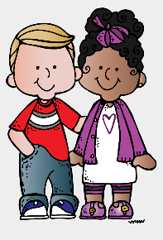 | PE  Have a go at these fun exercises with Lucy and her characters!  https://www.youtube.com/watch?v=BDYd2qFR45o  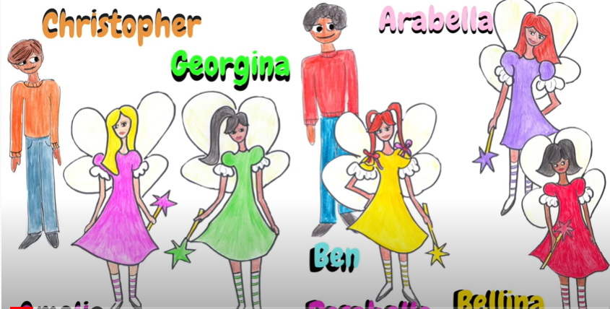 | FRENCH  Keep practicing your French numbers and colours with these videos.  https://www.youtube.com/watch?v=dhj9SqrIZqI  https://www.youtube.com/watch?v=kzR_d6uJkb8&t=7s  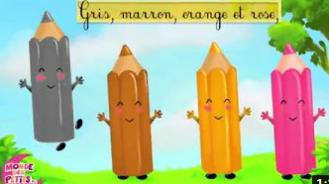 | ART  Have a go at drawing some fantastic spring pictures with the Art for Kids Hub team!  I am looking forward to seeing your amazing artwork!  https://www.youtube.com/watch?v=hgKIyhLUW6M  https://www.youtube.com/watch?v=JQSIsqC_8yw    https://www.youtube.com/watch?v=88K3ytkQlek

These activities are linked to some of the work that is being completed in class this week.
If you have any questions or would like to share with me what your child has done then please feel free to email me asayer@stmarysprimary.net
Please continue to read with your child using resources online, Kent Libraries or books from home.

