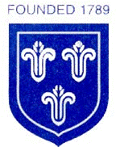
St Mary’s Church of England Primary School
Home Learning
Class 4 | Monday  1.3.2021 | Tuesday  2.3.2021 | Wednesday  3.3.2021 | Thursday  4.3.2021 | Friday  5.3.2021
Reading | Read every day to enhance your reading skills. Remember, reading does not just have to be books, it could be comics, online or newspapers. 10-15 minutes minimum every day.  Roald Dahl: ‘Billy and the Minpins’: https://www.youtube.com/watch?v=U70n1hRyL2A
Spellings | Recent, regular, reign, remember, sentence, special
Spellings | Write out the spellings in a list. Have a good look at them. What do you notice? Are there any patterns that you could use to help you remember the words?  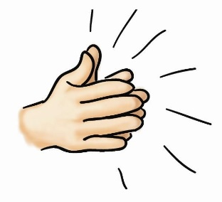  Say each word out loud and clap each letter. | Write your spellings in steps, starting with the first letter and then adding the next letter each time.  Eg: SPECIAL  S  SP  SPE  SPEC  SPECI  SPECIA  SPECIAL | Wonderful  Wednesday!  You have worked super hard so far this week! Time for a break and to have some fun!  I have attached a grid at the end of the document as well as a separate Word Document and PDF below.  Choose some of the activities that you would like to do – don’t forget to send me some photos of what you get up to today! | 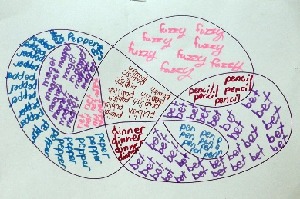  Create a spelling scribble by drawing lots of bubbles stuck together. Write your spellings into the spelling scribble, repeating them until you fill all the bubbles. | Time for a spelling test!  Make sure you have a plain piece of paper. Ask someone at home to read out your spellings one by one. As they read them, write them down on your piece of paper.  Once you have finished, ask someone to check your spellings.  How many did you get correct?  Please email me to let me know your score  asayer@stmarysprimary.net
Punctuation & Grammar | Complete the SPaG activities on the document below. | Complete the SPaG activities on the document below. |  | Complete the SPaG activities on the document below. | Complete the SPaG activities on the document below.
Literacy | Please complete lesson 5: ‘To develop a rich understanding of words associated with disgusting food’.  In this lesson you will be introduced to some new vocabulary and will be applying this vocabulary in sentences.  https://classroom.thenational.academy/lessons/to-develop-a-rich-understanding-of-words-associated-with-disgusting-food-60t32d | Please complete lesson 6:  ‘To generate vocabulary to use in our instructions’.  In this lesson you will be recapping imperative verbs and sequencing words. You will also be focusing on using adverbs.  https://classroom.thenational.academy/lessons/to-generate-vocabulary-to-use-in-our-instructions-cgu30c |  | Please complete lesson 7:  ‘To practise and apply knowledge of suffixes: -er and -est suffixes’.  In this lesson you will practise the rules associated with these suffixes.  https://classroom.thenational.academy/lessons/to-practise-and-apply-knowledge-of-suffixes-er-and-est-suffixes-including-test-6gwkje | Please complete lesson 8: ‘To orally rehearse our instructions’.  In this lesson you will be using adjectives to describe your ingredients.  https://classroom.thenational.academy/lessons/to-orally-rehearse-our-instructions-ccv32e
Mathematics | Complete lesson 9: ‘Comparing fractions with the same denominator.’  In this lesson you are going to be using pictorial representations to identify and compare the size of fractions with the same denominator.  https://classroom.thenational.academy/units/fractions-ed51 | Complete lesson 10: ‘Compare and order unit fractions.’  In this lesson you are going to be exploring the size of different unit fractions.  https://classroom.thenational.academy/units/fractions-ed51 |  | Complete lesson 11: ‘Fractions: Recognising equivalent fractions (Part 1).’  In this lesson you are going to be exploring fractions with different denominators and numerators.  https://classroom.thenational.academy/units/fractions-ed51 | Complete lesson 12: ‘Fractions: Recognising equivalent fractions (Part 2).’  In this lesson you are going to be exploring fractions with different denominators and numerators that are equal to each other.  https://classroom.thenational.academy/units/fractions-ed51
Times Tables | Practise your 4 times table with this song.  https://www.youtube.com/watch?v=w5ZM3YItes4&t=1s | Practise your 6 times table with this song.  https://www.youtube.com/watch?v=e7rYbk9PNuM |  | Practise your 8 times table with this song.  https://www.youtube.com/watch?v=C8b_Kj9bYHQ&t=2s | Practise your 9 times table with this song.  https://www.youtube.com/watch?v=H3BGwzdLDBY
Other Subjects | PSHE  Your first PSHE lesson this week is called ‘Be better and do more’. You will be learning about climate change and the causes and effects.    https://classroom.thenational.academy/lessons/be-better-and-do-more-6dgkcr | SCIENCE  In today’s Science lesson, you are going to be learning about famous Scientist Steven Hawking.  You will be creating your own script to present a Science topic of your choice.    https://classroom.thenational.academy/lessons/who-is-stephen-hawking-crr3jt |  | PSHE  Your second PSHE lesson this week is called ‘Biodiversity and Ecosystems.’ You will be learning what biodiversity means and what makes up an ecosystem.  https://classroom.thenational.academy/lessons/biodiversity-and-ecosystems-74u38c   | GEOGRAPHY  In today’s Geography lesson you will be learning about the geography of the Arctic and the Antarctic and finding similarities and differences between them.  https://classroom.thenational.academy/lessons/what-is-the-geography-of-the-arctic-and-antarctic-69gk4d  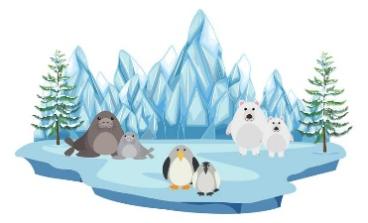
Other Subjects | ART  Hello to Spring! We will soon be saying hello to spring and all the lovely things that March brings.  The document below contains a poem about spring. Can you draw your vision when reading the poem? What does it make you think of?  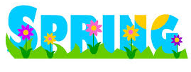 | COMPUTING  Today’s computing lesson sees the return of touch-typing practise! This is a key skill to master so keep practising!  https://www.typingclub.com/  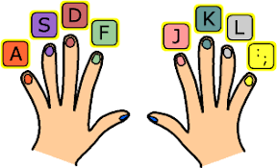 |  | WORLD BOOK DAY CELEBRATION  Today, it is World Book Day! I have included a link below to the World Book Day website which has some great free audiobooks for you to enjoy!  Once you have chosen a book, you might like to read the first few chapters and then create your own character for the story? Maybe you might like to create your own new front cover for the book? Could you write a book review for the book once you have finished it? What was the story about? What was your favourite part? Who would you recommend the book to?  https://www.worldbookday.com/world-of-stories/ | FRENCH  This BBC Bitesize French game will test your knowledge of the French language. Don’t worry if you do not get every answer correct, you are learning as you go!    https://www.bbc.co.uk/bitesize/topics/z74gcqt/articles/zyvnm39
Thinking Time | Your week ahead  Think about the week ahead of you.  How are you going to shine this week?  What can you do in the house to help adults at home?    How can you show a positive attitude this week? | Newsround  Watch Newsround to find out about the world. What new and interesting things will you learn today?  https://www.bbc.co.uk/newsround/news/watch_newsround   |  | Yoga  Have a go at some yoga with Cosmic Kids Yoga sessions!  There are lots to choose from on their YouTube channel.  https://www.youtube.com/results?sp=mAEB&search_query=cosmic+kids+yoga  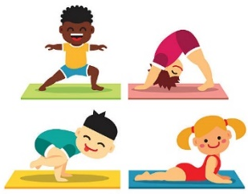 | Reflect  How has your week been?  What are you proud of this week?  What fun things are you looking forward to this weekend?  
Exercise and Break times | Get yourself moving and try to complete a Joe Wicks or Go Noodle workout once a day.  https://family.gonoodle.com/  https://www.youtube.com/watch?v=d3LPrhI0v-w  Chill out and relax by trying one of these children’s yoga videos.  https://www.youtube.com/user/CosmicKidsYoga | Get yourself moving and try to complete a Joe Wicks or Go Noodle workout once a day.  https://family.gonoodle.com/  https://www.youtube.com/watch?v=d3LPrhI0v-w  Chill out and relax by trying one of these children’s yoga videos.  https://www.youtube.com/user/CosmicKidsYoga |  | Get yourself moving and try to complete a Joe Wicks or Go Noodle workout once a day.  https://family.gonoodle.com/  https://www.youtube.com/watch?v=d3LPrhI0v-w  Chill out and relax by trying one of these children’s yoga videos.  https://www.youtube.com/user/CosmicKidsYoga | Get yourself moving and try to complete a Joe Wicks or Go Noodle workout once a day.  https://family.gonoodle.com/  https://www.youtube.com/watch?v=d3LPrhI0v-w  Chill out and relax by trying one of these children’s yoga videos.  https://www.youtube.com/user/CosmicKidsYoga

Please email me daily to let me know how you are getting on with the activities I have set you, if you could send me photographs of what you have been doing that would be great - I love to see your learning!
asayer@stmarysprimary.net

Build a cushion or duvet fort. |  | Wonderful Wednesday! |  | Paint a picture.
Go for a walk and get some fresh air. | Learn the words to a song you like. | Bake something yummy! | Write a post-card to a friend or family member. | Learn to master a new skill!
Watch your favourite movie. | Play with your toys. | Create a masterpiece from junk modelling! | Read a book, story or magazine. | Make up a story and publish it with a front cover and blurb.
Carry out a Science experiment. | Make some fruit kebabs. | Build a bug hotel using items from home. | Play outside. | Speak to a friend or family member on Zoom or on the phone.
Spend some time on Wednesdays completing some of these fun activities. You work so hard with your learning, it is important to take some time for you and have fun!

