
St Mary’s Church of England Primary School
Home Learning
Class 4 | Monday  22.2.2021 | Tuesday  23.2.2021 | Wednesday  24.2.2021 | Thursday  25.2.2021 | Friday  26.2.2021
Reading | Read every day to enhance your reading skills. Remember, reading does not just have to be books, it could be comics, online or newspapers. 10-15 minutes minimum every day.  Roald Dahl: ‘Billy and the Minpins’: https://www.youtube.com/watch?v=U70n1hRyL2A
Spellings | Potatoes, pressure, probably, promise, purpose, quarter, question
Spellings | Write out the spellings in a list. Have a good look at them. What do you notice? Are there any patterns that you could use to help you remember the words?  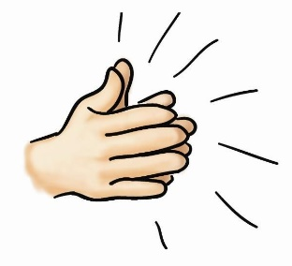  Say each word out loud and clap each letter. | Write your spellings in steps, starting with the first letter and then adding the next letter each time.  Eg: PROMISE  P  PR  PRO  PROM  PROMI  PROMIS  PROMISE | Wonderful  Wednesday!  You have worked super hard so far this week! Time for a break and to have some fun!  I have attached a grid at the end of the document as well as a separate Word Document and PDF below.  Choose some of the activities that you would like to do – don’t forget to send me some photos of what you get up to today! | 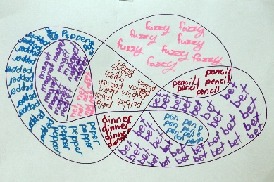  Create a spelling scribble by drawing lots of bubbles stuck together. Write your spellings into the spelling scribble, repeating them until you fill all the bubbles. | Time for a spelling test!  Make sure you have a plain piece of paper. Ask someone at home to read out your spellings one by one. As they read them, write them down on your piece of paper.  Once you have finished, ask someone to check your spellings.  How many did you get correct?  Please email me to let me know your score  asayer@stmarysprimary.net
Punctuation & Grammar | Please complete lesson 4: ‘To practise using simple past, present and future tense.’  https://classroom.thenational.academy/units/t3-punctuation-level-objectives-b1b0 | Please complete lesson 5: ‘To revise simple compound and complex sentences.’ https://classroom.thenational.academy/units/t3-punctuation-level-objectives-b1b0 |  | Complete the lesson to recap your knowledge and practise using expanded noun phrases.  https://www.bbc.co.uk/bitesize/topics/zwwp8mn/articles/z3nfw6f | Complete the lesson to recap your knowledge and practise using fronted adverbials.  https://www.bbc.co.uk/bitesize/topics/zwwp8mn/articles/zp937p3
Literacy | Please complete lesson 1: ‘To identify features of instructions.’  In this lesson you will be looking at sequencing words and imperative verbs.  https://classroom.thenational.academy/units/monster-pizza-instructions-9061 | Please complete lesson 2: ‘To investigate suffixes: -er and -est suffixes.’  In this lesson you will be exploring the rules associated with these suffixes.  https://classroom.thenational.academy/lessons/to-investigate-suffixes-er-and-est-suffixes-ccw32d |  | Please complete lesson 3: ‘To explore ‘being’ verbs.’  In this lesson you will be learning about different types of verbs to use in your writing.  https://classroom.thenational.academy/lessons/to-explore-being-verbs-6mr68r | Please complete lesson 4: ‘To devise ingredients for our monster pizza.’  In this lesson you will be looking at the ingredients for pizza and deciding which ingredients a monster might like.  https://classroom.thenational.academy/lessons/to-devise-ingredients-for-our-monster-pizza-cdgkcd
Mathematics | Complete lesson 5: ‘To describe unit and non-unit fractions.’  In this lesson you are going to be using your knowledge of unit fractions to explore the idea of non-unit fractions.  https://classroom.thenational.academy/units/fractions-ed51 | Complete lesson 6: ‘To identify and describe non-unit fractions.’  In this lesson you are going to be exploring shapes to begin to identify the non-unit fraction represented.’  https://classroom.thenational.academy/units/fractions-ed51 |  | Complete lesson 7: ‘Finding non-unit fractions of quantities.’  In this lesson you are going to be using a bar modelling strategy to help you calculate non-unit fractions of amounts.  https://classroom.thenational.academy/units/fractions-ed51 | Complete lesson 8: ‘Consolidating finding non-unit fractions of quantities.’  In this lesson you are going to be using your knowledge of non-unit fractions to find fractions of a given quantity.’  https://classroom.thenational.academy/units/fractions-ed51
Times Tables | Practise your 4 times table with this song.  https://www.youtube.com/watch?v=w5ZM3YItes4&t=1s | Practise your 6 times table with this song.  https://www.youtube.com/watch?v=e7rYbk9PNuM |  | Practise your 8 times table with this song.  https://www.youtube.com/watch?v=C8b_Kj9bYHQ&t=2s | Practise your 9 times table with this song.  https://www.youtube.com/watch?v=H3BGwzdLDBY
Other Subjects | RE  This is your fourth session about Gospel. You are going to be focusing on the three Bible stories we have looked at this term.  Read through the information and answer the questions based on your own thoughts.  Double click the Word or PDF document below to access today’s RE lesson. | PSHE  In your first PSHE lesson this week, you are going to be learning about a topic called ‘Our Wonderful World!’.  This lesson will be focused on H2O. You will be recapping the water cycle and thinking about how you can save water at home.  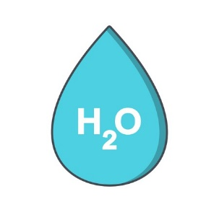  https://classroom.thenational.academy/lessons/h20-6dgk6t |  | GEOGRAPHY  In today’s Geography lesson, I am going to introduce you to a short sequence of lessons about Locational Knowledge.  Your first lesson is going to be about hemispheres. You are going to be learning about how the hemispheres split the world in half!  Remember to have a go at the end of lesson quiz to test your knowledge!  https://classroom.thenational.academy/lessons/what-are-the-hemispheres-6grp8e   | PSHE  In your second PSHE lesson this week, you are going to be focusing on recycling.  You will be learning about the terms reduce, reuse, recycle and using some household items to make your own product!  https://classroom.thenational.academy/lessons/reduce-reuse-recycle-crt38c  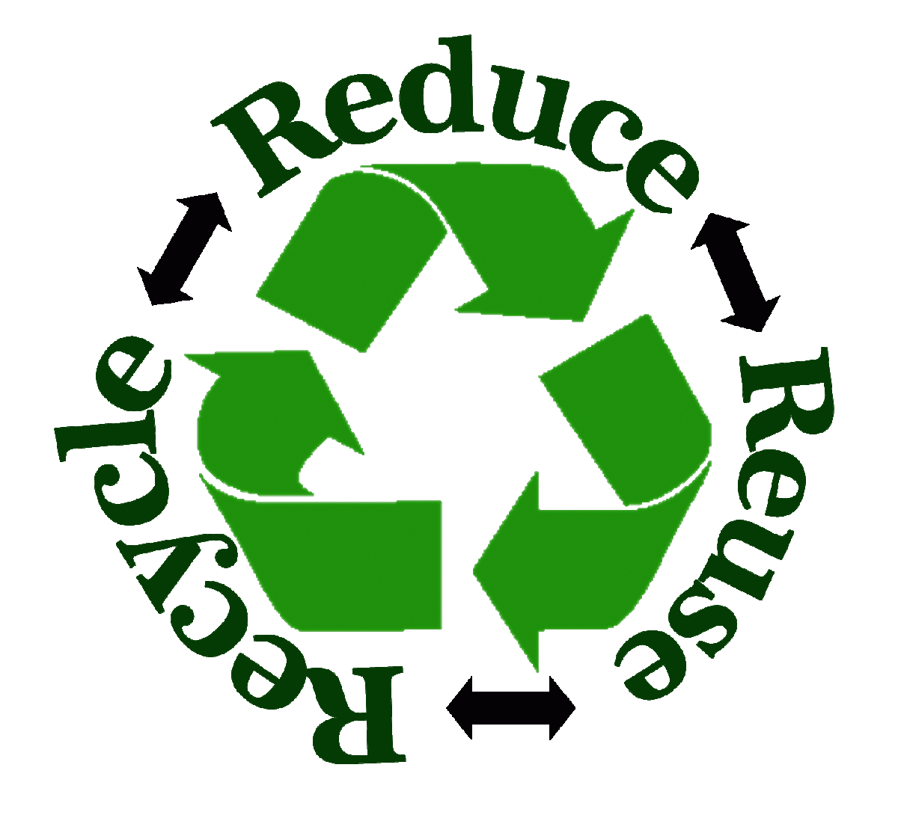
Other Subjects | MUSIC  I have found another body percussion video! I LOVE seeing your videos of these so please keep sending them!  Enjoy!  https://www.youtube.com/watch?v=j0il5yKUK3U  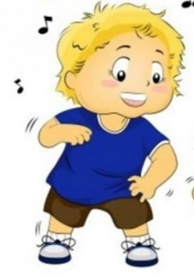 | ART  In today’s Art lesson, you have the opportunity to follow an Art for Kids Tutorial. What will you draw? Please send me your masterpieces, I would love to see them!  https://www.youtube.com/user/ArtforKidsHub  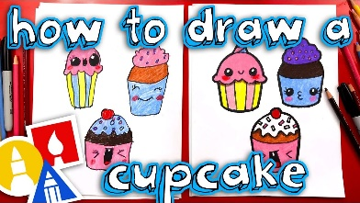 |  | READING COMPREHENSION  Today, I would like you to have a go at a reading comprehension about Doorstep Wildlife.  It is so important to be knowledgeable about the wildlife we have around us and to think about the things we can do to support their survival.  Please do not worry about printing the questions, just answer in full sentences on your paper. | FRENCH  In today’s French lesson, you are going to be learning to talk about food and drink in French.  You will learn to say which foods you like and dislike and different meal times during the day.  https://www.bbc.co.uk/bitesize/topics/zjcbrj6/articles/zfmq4xs  
Thinking Time | Think Positive  Think about the week ahead of you.  How are you going to shine this week?  What can you do in the house to help adults at home?  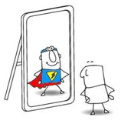  How can you show a positive attitude this week? | Yoga  Have a go at some yoga with Cosmic Kids Yoga sessions!  There are lots to choose from on their YouTube channel.  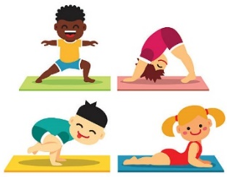  https://www.youtube.com/results?sp=mAEB&search_query=cosmic+kids+yoga |  | Newsround  Watch Newsround to find out about the world. What new and interesting things will you learn today?  https://www.bbc.co.uk/newsround/news/watch_newsround   | Reflect  How has your week been?  What are you proud of this week?  What fun things are you looking forward to this weekend?  
Exercise and Break times | Get yourself moving and try to complete a Joe Wicks or Go Noodle workout once a day.  https://family.gonoodle.com/  https://www.youtube.com/watch?v=d3LPrhI0v-w  Chill out and relax by trying one of these children’s yoga videos.  https://www.youtube.com/user/CosmicKidsYoga | Get yourself moving and try to complete a Joe Wicks or Go Noodle workout once a day.  https://family.gonoodle.com/  https://www.youtube.com/watch?v=d3LPrhI0v-w  Chill out and relax by trying one of these children’s yoga videos.  https://www.youtube.com/user/CosmicKidsYoga |  | Get yourself moving and try to complete a Joe Wicks or Go Noodle workout once a day.  https://family.gonoodle.com/  https://www.youtube.com/watch?v=d3LPrhI0v-w  Chill out and relax by trying one of these children’s yoga videos.  https://www.youtube.com/user/CosmicKidsYoga | Get yourself moving and try to complete a Joe Wicks or Go Noodle workout once a day.  https://family.gonoodle.com/  https://www.youtube.com/watch?v=d3LPrhI0v-w  Chill out and relax by trying one of these children’s yoga videos.  https://www.youtube.com/user/CosmicKidsYoga

Please email me daily to let me know how you are getting on with the activities I have set you, if you could send me photographs of what you have been doing that would be great - I love to see your learning!
asayer@stmarysprimary.net

