
St Mary’s Church of England Primary School
Home Learning
Class 4 | Monday  8.2.2021 | Tuesday  9.2.2021 | Wednesday  10.2.2021 | Thursday  11.2.2012 | Friday  12.2.2021
Reading | Read every day to enhance your reading skills. Remember, reading does not just have to be books, it could be comics, online or newspapers. 10-15 minutes minimum every day.  Use this link to access Jeff Kinney ‘Diary of a Wimpy Kid ’. You can choose to read some of the book yourself on the screen or listen to the book being read to you. Maybe you could do a bit of both! Enjoy!  https://www.youtube.com/watch?v=cy0jEVm002w  Did you enjoy this book? Email me to let me know what you thought! asayer@stmarysprimary.net
Spellings | Particular, peculiar, perhaps, popular, position, possess, possession, possible.
Spellings | Write out the spellings in a list. Have a good look at them. What do you notice? Are there any patterns that you could use to help you remember the words?  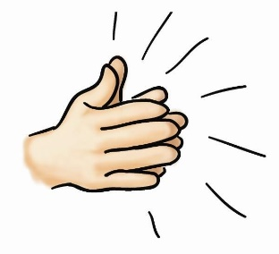  Say each word out loud and clap each letter. | Write your spellings in steps, starting with the first letter and then adding the next letter each time.  Eg: possible  P  PO  POS  POSS  POSSI  POSSIB  POSSIBL  POSSIBLE | Wonderful  Wednesday!  You have worked super hard so far this week! Time for a break and to have some fun!  I have attached a grid at the end of the document as well as a separate Word Document and PDF below.  Choose some of the activities that you would like to do – don’t forget to send me some photos of what you get up to today! | Write your spellings in different colours and fonts.  Can you use a font that you’ve never used before?  Can you create some patterns on your spellings?  Can you write your spellings backwards?  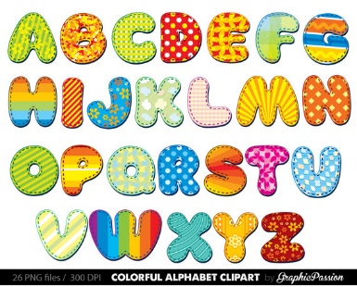 | Time for a spelling test!  Make sure you have a plain piece of paper. Ask someone at home to read out your spellings one by one. As they read them, write them down on your piece of paper.  Once you have finished, ask someone to check your spellings.  How many did you get correct?  Please email me to let me know your score  asayer@stmarysprimary.net
Punctuation & Grammar | Please complete lesson 5: ‘To revise our knowledge of word class.’  https://classroom.thenational.academy/units/t2-word-level-objectives-8c26 | Please complete lesson 1: ‘To explore the function of apostrophes.’  https://classroom.thenational.academy/units/t3-punctuation-level-objectives-b1b0 |  | Please complete lesson 2: ‘To explore punctuating speech first.’  https://classroom.thenational.academy/units/t3-punctuation-level-objectives-b1b0 | Please complete lesson 3: ‘To revise speech punctuation.’  https://classroom.thenational.academy/units/t3-punctuation-level-objectives-b1b0
Literacy | In today’s Literacy lesson you will be focusing on using speech with the correct punctuation.  Please complete lesson 10: ‘To practise speech with punctuation’.  https://classroom.thenational.academy/units/the-borrowers-narrative-writing-c96c  Don’t forget to email me to show me how you are getting on. I would love to see your work!  asayer@stmarysprimary.net | In today’s Literacy lesson you will be generating vocabulary for the build-up scene in ‘The Borrowers’.  Please complete lesson 11: ‘To generate vocabulary for the build- up’.  https://classroom.thenational.academy/units/the-borrowers-narrative-writing-c96c  Don’t forget to email me to show me how you are getting on. I would love to see your work!  asayer@stmarysprimary.net |  | In today’s Literacy lesson you will be planning your ideas and generating vocabulary that can be applied to your writing.  Please complete lesson 12: ‘To plan the build -up’.  https://classroom.thenational.academy/units/the-borrowers-narrative-writing-c96c  Don’t forget to email me to show me how you are getting on. I would love to see your work!  asayer@stmarysprimary.net | In today’s Literacy lesson you will be learning how to use your plan effectively to apply to your writing and construct sentences for the build-up.  Please complete lesson 13: ‘To write the build-up’.  https://classroom.thenational.academy/units/the-borrowers-narrative-writing-c96c  Don’t forget to email me to show me how you are getting on. I would love to see your work!  asayer@stmarysprimary.net
Mathematics | Complete lesson 1: ‘To describe the part whole relationship’.  In this lesson you are going to be exploring and describing the part-whole relationship.  https://classroom.thenational.academy/units/fractions-ed51 | Complete lesson 2: ‘To recognise parts that are equal and parts that are unequal’.  In this lesson you are going to be building on your understanding of the whole and parts of a whole.  https://classroom.thenational.academy/units/fractions-ed51 |  | Complete lesson 3: ‘To recognise, identify and describe unit fractions’.  In this lesson you are going to be focusing on sharing amounts equally.  https://classroom.thenational.academy/units/fractions-ed51 | Complete lesson 4: ‘To find unit fractions of a given quantity’.  In this lesson you are going to be finding different fractions in contexts.  https://classroom.thenational.academy/units/fractions-ed51
Times Tables | Practise your 4 times table with this song.  https://www.youtube.com/watch?v=w5ZM3YItes4&t=1s | Practise your 6 times table with this song.  https://www.youtube.com/watch?v=e7rYbk9PNuM |  | Practise your 8 times table with this song.  https://www.youtube.com/watch?v=C8b_Kj9bYHQ&t=2s | Practise your 9 times table with this song.  https://www.youtube.com/watch?v=H3BGwzdLDBY
Other Subjects | PSHE  Welcome to our new PSHE topic, ‘Think Positive’.  This lesson we are focusing on ‘Happy minds, Happy people’. Your aim is to understand that having a positive attitude is good for our mental health.  Have a look through the PowerPoint sides and think about having a positive attitude and how this can make you happy.  Once you have read through the PowerPoint, have a go at creating your own list poem. Every line starts with ‘Happiness is’. You can make your poem as long as you like.  Double click the PowerPoint or PDF document below to access today’s PSHE lesson.  Here are a few ideas to get you started:  Happiness is spending time with loved ones.  Happiness is seeing the sun shining through the window.  Happiness is hearing the birds sing their carefree song.  Happiness is smiling at someone and they smile at you too.  Happiness is blowing out the candles and eating a huge slice of birthday cake.  Happiness is waking up in the morning and being glad to be you.  Please share your poems with me once you have finished. I can’t wait to read them! | SCIENCE  Today’s Science lesson is about Separation.  Watch the video and complete the interactive activities.  Imagine you are telling an alien about what separation is. They have never heard of it before, can you explain?  https://www.bbc.co.uk/bitesize/topics/zcvv4wx/articles/zw7tv9q  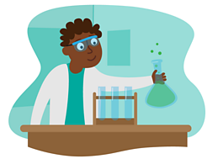 |  | ART  In this lesson you will be learning how to weave with paper.  https://classroom.thenational.academy/lessons/an-introduction-to-creative-crafts-and-experimentation-with-paper-weaving-cmu64e?activity=video&step=1  If you manage to complete this lesson please send me what you have created! I would love to see!  asayer@stmarysprimary.net  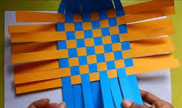 | HISTORY/GEOGRAPHY  In today’s History lesson you are going to be learning about why Boudicca lead a revolt against the Romans.  Who were the Iceni Tribe?  How did Boudicca fight back against the Romans?  https://classroom.thenational.academy/lessons/why-did-boudicca-lead-a-revolt-against-the-romans-60v3gc  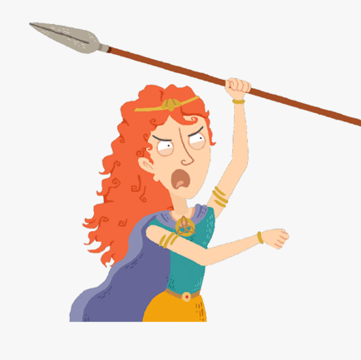
Other Subjects | HANDWRITING  Today, you have the chance to finish practising your cursive letters.  Start the video at 6:14, this will enable you to continue from Tuesday with the letter n.  Remember to watch the letter being formed 3 times before pausing the video and having a go yourself.  https://www.youtube.com/watch?v=2NQ6uS8blwY  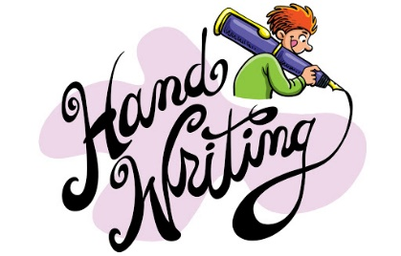 | READING COMPREHENSION  Today, I would like you to have a go at this reading comprehension and answering the questions.  Remember, the answers are always in the text unless the question is asking you for your opinion.  You need to try to answer in full sentences, which means including some of the question in your answer.  EG. Why did Tom jump over the gate?  Tom jumped over the gate because he was being chased by a dog. |  | COMPUTING  In today’s computing lesson you have the chance to have a go at some great coding games and tasks.  I really enjoyed these!  I hope you do too  https://blockly.games/  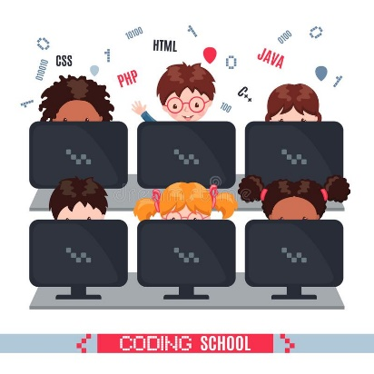 | FRENCH  In today’s French lesson, you are going to be focusing on talking about school.  You will be learning how to talk about things you like and don’t like about school, as well as how to say each subject and objects we might find at school and the days of the week.  Can you make up some sentences and say them to someone at home?  https://www.bbc.co.uk/bitesize/topics/zjcbrj6/articles/z4q8g7h  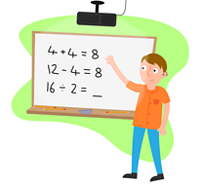
Thinking Time | Butterfly Breaths  Have a go at this breathing exercise to help calm your mind and to help you start the week positively and calmly.  Double click the Word Document or PDF to access the instructions. | Newsround  Watch Newsround to find out about the world. What new and interesting things will you learn today?  https://www.bbc.co.uk/newsround/news/watch_newsround   |  | Sun Breaths  Have a go at this breathing exercise. These are great top calm your mind and body. What faraway place will you think about?  Double click the Word Document or PDF to access the instructions. | Reflect  How has your week been?  What are you proud of this week?  What fun things are you looking forward to this weekend?  
Exercise and Break times | Get yourself moving and try to complete a Joe Wicks or Go Noodle workout once a day.  https://family.gonoodle.com/  https://www.youtube.com/watch?v=d3LPrhI0v-w  Chill out and relax by trying one of these children’s yoga videos.  https://www.youtube.com/user/CosmicKidsYoga | Get yourself moving and try to complete a Joe Wicks or Go Noodle workout once a day.  https://family.gonoodle.com/  https://www.youtube.com/watch?v=d3LPrhI0v-w  Chill out and relax by trying one of these children’s yoga videos.  https://www.youtube.com/user/CosmicKidsYoga |  | Get yourself moving and try to complete a Joe Wicks or Go Noodle workout once a day.  https://family.gonoodle.com/  https://www.youtube.com/watch?v=d3LPrhI0v-w  Chill out and relax by trying one of these children’s yoga videos.  https://www.youtube.com/user/CosmicKidsYoga | Get yourself moving and try to complete a Joe Wicks or Go Noodle workout once a day.  https://family.gonoodle.com/  https://www.youtube.com/watch?v=d3LPrhI0v-w  Chill out and relax by trying one of these children’s yoga videos.  https://www.youtube.com/user/CosmicKidsYoga

Please email me daily to let me know how you are getting on with the activities I have set you, if you could send me photographs of what you have been doing that would be great - I love to see your learning!
asayer@stmarysprimary.net

Bake something yummy! | Wonderful Wednesday! |  |  | Learn to master a new skill!
Go for a walk and get some fresh air. | Build a cushion or duvet fort. | Make a sandwich with your favourite fillings. | Write a post-card to a friend or family member. | Spend some time chatting to a loved one at home.
Watch your favourite T.V show. | Have a pyjama day! | Read a book, story or magazine. | Play with your toys. | Make some playdough using hair conditioner and cornflour.
Paint a picture. | Watch a movie with someone at home. | Speak to a friend or family member on Zoom or on the phone. | Create a masterpiece from junk modelling! | Play outside.
Spend some time on Wednesdays completing some of these fun activities. You work so hard with your learning, it is important to take some time for you and to have fun! Please send me some photos of anything you get up to – I would love to see!

