W/C 25/01/21 | Monday |  |  |  | Tuesday |  | Wednesday |  |  |  | Thursday | Friday
9:00 - 9:10 | Daily Exercise:  Jo Wicks Work Out  https://www.youtube.com/playlist?list=PLyCLoPd4VxBvPHOpzoEk5onAEbq40g2-k |  |  |  | Daily Exercise:  Yoga  https://www.youtube.com/channel/UC5uIZ2KOZZeQDQo_Gsi_qbQ |  | Daily Exercise:  GoNoodle  https://family.gonoodle.com/ |  |  |  | Daily Exercise:  Jo Wicks Work Out  https://www.youtube.com/playlist?list=PLyCLoPd4VxBvPHOpzoEk5onAEbq40g2-k | Daily Exercise:  Yoga  https://www.youtube.com/channel/UC5uIZ2KOZZeQDQo_Gsi_qbQ
Reading:
Whilst your child is away from school it is important that they continue to take some time to read each day.
Have a go at reading a book that you already have at home.

 | Spellings:  Myth Symbol  Gym Lyric  Egypt Typical  Pyramid  Mystery  Hymn  System  What sound does the ‘y’ make?  Have a go at saying your spellings aloud and clap each letter as you say it.  Please click here if you wish to download the PDF. Only use pages 1-3 this week. |  |  | Can you write out a list of your spellings using different coloured pens or pencils?  How many different colours and styles of writing can you write these words in? |  |  |  | Can you find a definition for each of your spellings?  Use the link to help you find the definition, then write your definition next to the spelling.  https://kids.wordsmyth.net/we/ |  | Spellings:  Myth Symbol  Gym Lyric  Egypt Typical  Pyramid  Mystery  Hymn  System  Complete the Look, Cover, Say, Write document below. |  | Time for a spelling test!  Make sure you have a plain piece of paper. Ask someone at home to read out your spellings one by one. As they read them, write them down on your piece of paper.  Once you have finished, ask someone to check your spellings.  How many did you get correct? Please email me to let me know your score.
Literacy  9:15- 10:00 | Starter:  Spelling –cious and –tious  https://www.bbc.co.uk/bitesize/topics/zt62mnb/articles/zp7dk7h  Task:  Click the link below to take you to the lesson. This week’s lessons are all about The BFG.  https://classroom.thenational.academy/lessons/to-generate-vocabulary-for-character-description-6rtkct |  |  | Starter:  Suffix –ous  https://www.bbc.co.uk/bitesize/topics/zqqsw6f/articles/zqcpv9q  Task:  https://classroom.thenational.academy/lessons/to-practise-and-apply-knowledge-of-suffixes-past-and-present-tense-including-a-test-61h3ce |  |  |  | Starter:  Adjectives  https://www.bbc.co.uk/bitesize/articles/zf6c47h  Task:  https://classroom.thenational.academy/lessons/to-analyse-the-opening-scene-70u36t |  | Task:  Click the link below to take you to today’s lesson.  https://classroom.thenational.academy/lessons/to-write-the-first-part-of-the-opening-part-2-ccr36t |  | Starter:  Fronted Adverbials  https://www.bbc.co.uk/bitesize/topics/zwwp8mn/articles/zp937p3  Task:  Click the link below to take you to today’s lesson.  https://classroom.thenational.academy/lessons/to-write-the-second-part-of-the-opening-part-1-crtk4c
Break

10:00 - 10:30
Mathematics  10:30 - 11:15 |  | For each day I have provided a link to a video lesson, every lesson includes suggested activities the children could carry out.  I have also included additional activities that your child can complete as an extension which is based on our prior learning this school year.
Starter: Practice your times tables. Please focus on your 3,4 and 8 times tables.
Here are some links which will allow you to practice your times tables.
Times Tables Songs:
The 3 times table
https://www.bbc.co.uk/bitesize/articles/zk6vn9q

The 4 times table
https://www.bbc.co.uk/bitesize/articles/zfsqkty
The 8 times table
https://www.bbc.co.uk/bitesize/articles/zrrbsk7

Times Tables Games:
https://www.topmarks.co.uk/maths-games/7-11-years/times-tables
https://www.timestables.co.uk/games/

 |  | Task:  Lesson 1:  Converting Pounds and Pence  https://vimeo.com/497942634  Remember to pause the video each time to have a go at answering the questions.  Please record your answers on a piece of paper.  Extension:  Practice your times tables using this booklet. | Task:  Lesson 2:  Adding Money  https://vimeo.com/498286318  Extension:  Have a go at this multiplication and division (2) workbook.  https://wrm-13b48.kxcdn.com/wp-content/uploads/2020/07/Y3-HL-Spring-Block-1-Multiplication-and-division-2-2020.pdf |  |  | Task:  Lesson 3:  Subtracting Money  https://vimeo.com/498297373  Extension:  Continue with the multiplication and division workbook. |  |  | Task:  Lesson 4:  Give Change:  https://vimeo.com/499227948  Extension:  Have a try at some multiplication and division games.  https://www.topmarks.co.uk/maths-games/7-11-years/multiplication-and-division |  |  | Task:  Lesson 5:  Money Problem solving questions.  Click on the PDF below to access the math’s challenge questions for today’s learning activity.  Extension:  Have a try at some multiplication and division games.  https://www.topmarks.co.uk/maths-games/7-11-years/multiplication-and-division
Lunch Break

11:45 - 13:00
Afternoon Activity  13:00 - 14:30 |  | Geography:  Follow the link below to learn more about the geography of Wales.  https://classroom.thenational.academy/lessons/what-is-the-geography-of-wales-61jpar?step=2&activity=video | RE:  Watch the following video to recap our learning on the Trinity.  https://www.bing.com/videos/search?q=what+is+the+trinity+ks2&&view=detail&mid=112CB27CE6833767AF3E112CB27CE6833767AF3E&&FORM=VRDGAR&ru=%2Fvideos%2Fsearch%3Fq%3Dwhat%2Bis%2Bthe%2Btrinity%2Bks2%26FORM%3DHDRSC3  Complete the questions on the following worksheets. |  |  | Science:  Click on the following link to find out how fossils are made!  https://www.bbc.co.uk/bitesize/topics/z9bbkqt/articles/z2ym2p3  Watch the learning video and then have a go at the sequencing activity.  Using the PDF below to help you can you draw a picture an label the process of fossilisation. |  |  | Computing:  Try out one of the Hour of Code activities from Code.org - https://code.org/hourofcode/overview  Each tutorial gives step by step explanation about what to do. |  |  | Art:  Watch this video on what a collage is.  https://www.bbc.co.uk/teach/class-clips-video/art-and-design-ks1-ks2-creating-a-collage-landscape/zfrfbdm  Please send me photos of your work.  Using one of the following photos sketch the background and using materials that you have at home such a colouring pencils, paint or coloured paper create a collage.

Reflection  2:30-3:00 | Monday  Mindfulness: The Gratitude Tree:  At the moment things are different, but we need to focus on the positives we do have in difficult time and there are lots of things to grateful for even now.  Can you complete the gratitude meditation? This will help you think about all the things you might be grateful for.  https://insighttimer.com/thehappyhabit/guided-meditations/growing-gratitude-meditation-for-kids  We are going to make a gratitude tree: there are many ways you can do this – draw, cut one out, roll up some newspaper, or collect actual sticks if you are able to – be creative! Here are some examples: | Tuesday  Choose a mindfulness activity to complete by clicking the image below. | Wednesday  Complete one of the activities from the PSHE Poster by clicking the image below. | Thursday  Watch news round  https://www.bbc.co.uk/newsround  What important events have happened this week? | Friday  What do you feel proud of achieving this week?  What is something you would like to work on next week?

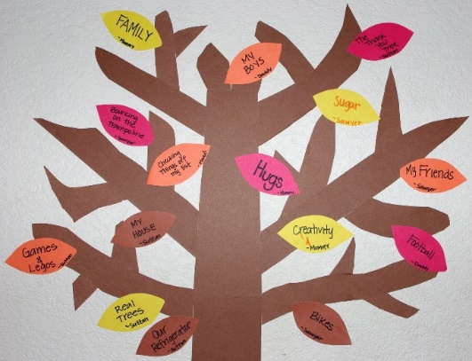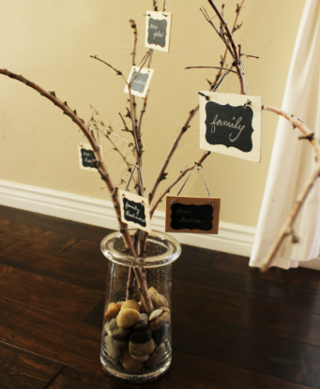 Each day I want you to think of something that you are grateful for – from people around you, your favourite food or toy, the weather … anything! Each day I want to write down the things you are grateful for and add it to your tree, so when you need to you can look at them and remember the good things.

