
St Mary’s Church of England Primary School
Home Learning
Class 4 | Monday | Tuesday | Wednesday | Thursday | Friday
Reading | Read every day to enhance your reading skills. Remember, reading does not just have to be books, it could be comics, online or newspapers. 10-15 minutes minimum every day.  Use this link to access Roald Dahl ‘Charlie and the Chocolate Factory’. You can choose to read some of the book yourself on the screen or listen to the book being read to you. Maybe you could do a bit of both! Enjoy!  https://www.youtube.com/watch?v=qCuNSZjCKg8
Spellings | imagine, increase, important, interest, island, knowledge
Spellings | Write out the spellings in a list. Have a good look at them. What do you notice? Are there any patterns that you could use to help you remember the words?  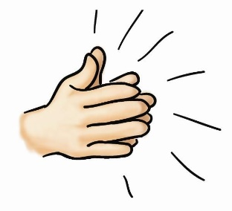  Say each word out loud and clap each letter. | Write your spellings in different colours and fonts.  Can you use a font that you’ve never used before?  Can you create some patterns on your spellings?  Can you write one of your spellings round in a circle so the first and last letter touch each other?  In a circle like this | Can you write your spellings out in a list and find a definition to write next to each one? What do our spellings mean this week?  You might use a dictionary if you have one at home, or Google search.   | Write six sentences using at least one of your spellings in each sentence.  Eg: The island looked deserted, but I couldn’t wait to find out what we might see.  It is important to brush your teeth twice a day to keep your mouth healthy. | Time for a spelling test!  Make sure you have a plain piece of paper. Ask someone at home to read out your spellings one by one. As they read them, write them down on your piece of paper.  Once you have finished, ask someone to check your spellings.  How many did you get correct? Please email me to let me know your score
Punctuation & Grammar | Commas  Watch the video and complete the interactive activities to learn how to use commas in a sentence.  https://www.bbc.co.uk/bitesize/topics/zvwwxnb/articles/zc773k7   | Semi- colons  Watch the video and complete the quiz to learn how to use a semi-colon.  https://www.bbc.co.uk/bitesize/topics/zvwwxnb/articles/zshfdxs  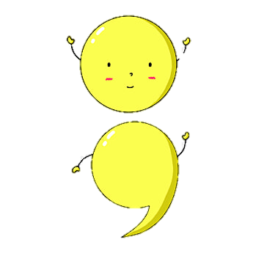 | Colons and Semi-colons  Watch the video and complete the interactive activities to learn more about colons and semi-colons. https://www.bbc.co.uk/bitesize/articles/zjhxwnb#z4bgsk7  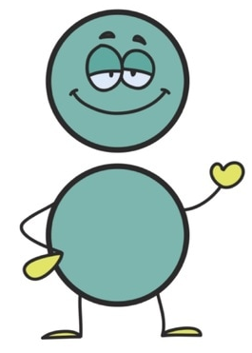 | Grammar Game  This is a fun game to test your knowledge of full stops, colons, semi-colons and full stops.  Be aware, that a full stop is not only used at the end of a sentence, it is used after a name and in some names of places.  Eg:  Mr. Smith  U.S.A.  https://mrnussbaum.com/the-semicolon-wars-the-fight-for-punctuation-island-online-game | Hyphens and Dashes  Watch the video and complete the interactive activities to learn how to use hyphens and dashes.  https://www.bbc.co.uk/bitesize/topics/zvwwxnb/articles/zg8gbk7
Literacy | In today’s Literacy lesson you will be building on the learning you completed in Literacy last week. You will be thinking about the different snacks we like to eat and creating a persuasive sentence for a healthy snack.  Please complete lesson 6: ‘To design a healthy snack’.  https://classroom.thenational.academy/units/healthy-food-persuasive-writing-2b8f | In today’s Literacy lesson you will be continuing to practise your use of suffixes.  Please complete lesson 7: ‘To practise and apply knowledge of suffixes: More –er and –est, including test’.  https://classroom.thenational.academy/units/healthy-food-persuasive-writing-2b8f | In today’s Literacy lesson you will be thinking back to last week when you looked at comparatives and superlatives. You will be looking for some new techniques today: alliteration, rhyme, adjectives and slogans.  Can you remember what any of these are before starting the video?  Please complete lesson 8: ‘To build persuasive vocabulary to use in our advert’.  https://classroom.thenational.academy/units/healthy-food-persuasive-writing-2b8f | In today’s Literacy lesson you will be exploring complex sentences with subordinating conjunctions (sounds scary, but don’t worry – you use them all the time without knowing it!)  You are going to be writing your own complex sentences using scientific vocabulary, comparatives or superlatives.  Please complete lesson 9: ‘To write complex sentences about our healthy snack’.  https://classroom.thenational.academy/units/healthy-food-persuasive-writing-2b8f | In today’s Literacy lesson you will be thinking about the learning that you have completed over the past 2 weeks. This will help you to create your own advertisement for a healthy snack.  I cannot wait to see what you have created!  Please complete lesson 10: ‘To design and write an advertisement for a healthy snack’.  https://classroom.thenational.academy/units/healthy-food-persuasive-writing-2b8f
Mathematics | In today’s maths lesson you are going to be learning how to multiply 2-digit numbers by 1-digit numbers using different methods. Which method do you feel works best for you?  Please complete lesson 1: ‘Multiply 2-digits by 1-digit (1)’.  Please do not worry about printing any worksheets or resources. Completing the work on paper will be great  https://whiterosemaths.com/homelearning/year-4/spring-week-2-number-multiplication-division/  *Challenge: Click on the PDF document below to access today’s challenge question. | In today’s maths lesson you are going to continue multiplying 2-digit numbers by 1-digit numbers.  Please complete lesson 2: ‘Multiply 2-digits by 1-digit’.  Please do not worry about printing any worksheets or resources. Completing the work on paper will be great  https://whiterosemaths.com/homelearning/year-4/spring-week-2-number-multiplication-division/  *Challenge: Click on the PDF document below to access today’s challenge question. | In today’s maths lesson you are going to be learning how to multiply 3-digit numbers by 1-digit numbers using different methods.  Please complete lesson 3: ‘Multiply 3-digits by 1-digit’.  Please do not worry about printing any worksheets or resources. Completing the work on paper will be great  https://whiterosemaths.com/homelearning/year-4/spring-week-2-number-multiplication-division/  *Challenge: Click on the PDF document below to access today’s challenge question. | In today’s maths lesson you are going to be working on your division skills. You will be dividing 2-digit numbers by 1-digit numbers using different methods. Have a go at using all the methods, which method works best for you?  Please complete lesson 4: ‘Divide 2-digits by 1-digit (2)’.  Please do not worry about printing any worksheets or resources. Completing the work on paper will be great  https://whiterosemaths.com/homelearning/year-4/spring-week-2-number-multiplication-division/  *Challenge: Click on the PDF document below to access today’s challenge question. | In today’s maths lesson you are going to continue dividing 2-digit numbers by 1-digit numbers.  Please complete lesson 5: ‘Divide 2-digits by 1-digit (1)’  Please do not worry about printing any worksheets or resources. Completing the work on paper will be great  https://whiterosemaths.com/homelearning/year-4/spring-week-2-number-multiplication-division/  *Challenge: Click on the PDF document below to access today’s challenge question.
Times Tables | Six Times tables  Click the box that says ‘Six Times Tables’ to practise.  https://www.mathsisfun.com/timestable.html  How many did you get correct? | Seven Times tables  Click the box that says ‘Seven Times Tables’ to practise.  https://www.mathsisfun.com/timestable.html  How many did you get correct? | Nine Times tables  Click the box that says ‘Nine Times Tables’ to practise.  https://www.mathsisfun.com/timestable.html  How many did you get correct? | Which times tables will you practise today? https://www.timestables.co.uk/ | Have fun practising your times tables! Can you challenge yourself?  https://mathsframe.co.uk/en/resources/resource/318/Tommys-Trek-Times-Tables
Other Subjects | RE  This is your first main session about Gospel. Read through the information and answer the questions based on your own thoughts.  Double click the PDF document below to access today’s RE lesson.   | SCIENCE  Complete the lesson to find out about evaporation and condensation. You should have an idea of what these words are already from our last topic, so use this lesson as a reminder and to further your knowledge.  https://www.bbc.co.uk/bitesize/topics/zkgg87h/articles/zydxmnb  Do you see condensation or evaporation happening anywhere around your home? Keep an eye out to see if you can spot any. | PSHE  This lesson is about Rules, Laws and Responsibilities. Your aim is to talk about what rules and laws are and identify how they can help us.  Double click the PDF document below to access today’s PSHE lesson.   | ART  Your art lesson this week is going to be linked to what you have been focusing on in Literacy. You have been thinking about and creating an advertisement for a healthy snack. In your lesson today, I would like you to try some still life drawing.  Still life drawing is when you have something in front of you and you sketch it, trying to include as much detail as possible. Today, I would like you to sketch some fruit or veg. If you have some at home, gather it together and sit in front of it. Look at the detail, the small lines, different colours, shapes. Then begin sketching the outline, adding in the details as you go.  Take your time and be proud of what you create. I cannot wait to see your masterpieces!  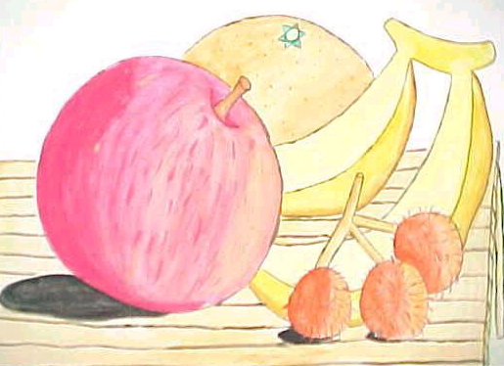  Here is an example if you are stuck. | HISTORY/GEOGRAPHY  In today’s History lesson you are going to be learning about how the Roman’s conquered Britain.  You will be looking at some key people who were around during that time and what they did.  https://www.bbc.co.uk/bitesize/topics/zqtf34j/articles/z9j4kqt  What do you think it would have been like to fight for a Roman army?  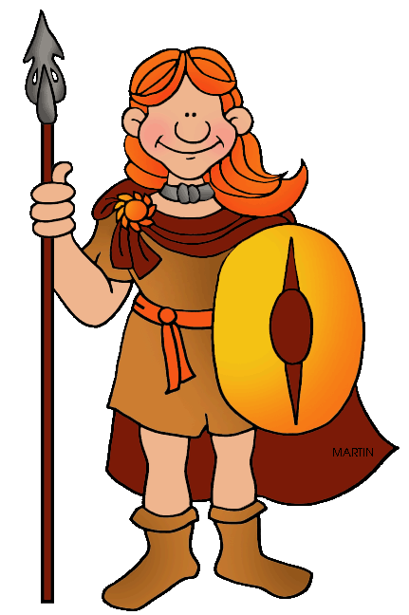
Other Subjects | MUSIC  In this lesson you are going to be learning about pulse and rhythm.  What is a good example of a pulse?  Can you create your own rhythm using clapping, tapping or banging?  https://www.bbc.co.uk/bitesize/topics/zcbkcj6/articles/z2mqw6f   | HANDWRITING  In today’s handwriting lesson I would like you to keep practising your joining. It is important to try to join all the letters if you can (apart from capital letters).  Think about making sure your letters are similar in size and that they all upright, not slanted.  Have a go at writing this week’s spellings in your neatest handwriting.  Remember to take your time and to join ALL your letters!  Here is the cursive writing poster to help with forming your letters if you need it. | COMPUTING  In today’s Computing lesson I would like you to have a go at Dance mat typing.  This is similar to the touch typing lesson you had last week but using a different website.  I hope you enjoy it!  https://www.bbc.co.uk/bitesize/topics/zf2f9j6/articles/z3c6tfr  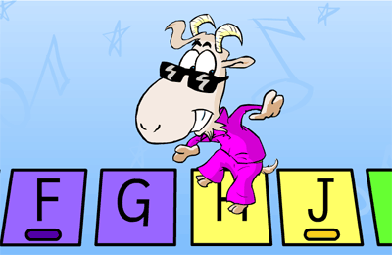 | HANDWRITING  In today’s handwriting lesson, I would like you to practise your pencil control.  Have a go at copying these patterns. Make sure you complete a whole line of each pattern without taking your pencil off the paper.  Keep breathing steadily as you write, keep your pencil comfortably in your hand and focus on each part of the pattern as you move.  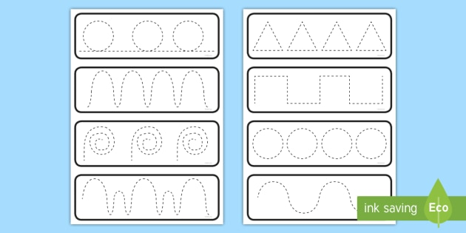  This activity will help to make your writing neater and more fluid. | FRENCH  In this lesson you are going to be talking about yourself in French.  We have had a go at some of this in the classroom so some of you might know some of the words already!  Read and listen to the sentences and then try to create your own.  Can you say them to someone else in your house?  Can you write your sentences down and draw pictures to help you remember what each sentence says?    https://www.bbc.co.uk/bitesize/topics/zjcbrj6/articles/zgnwr2p
Thinking Time | Think about the week ahead of you.  How are you going to shine this week?  What can you do in the house to help adults at home?  How can you show a positive attitude this week?   | Watch Newsround to find out about the world. What new and interesting things will you learn today?  https://www.bbc.co.uk/newsround/news/watch_newsround   | Have a go at some Mindfulness Meditation. This video will help you to feel relaxed and grounded. It is very peaceful.  https://www.youtube.com/watch?v=Bk_qU7l-fcU  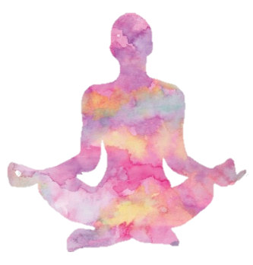 | Mindfulness Safari  (You can complete this task either out on a walk with your family or from a window in your house.)  Your goal is to notice as many birds, bugs, creepy-crawlies, and any other animals as you can. Anything that walks, crawls, swims, or flies is of interest, and you will need to focus all your senses to find them, especially the little ones.  I’d love to know how you get on and what you see! | Reflect upon your week. What went well?  What could have gone better?  Did you do something to help around the house?  Have you had a positive attitude next week?  What are you looking forward to this weekend?  
Exercise and Break times | Get yourself moving and try to complete a Joe Wicks or Go Noodle workout once a day.  https://family.gonoodle.com/  https://www.youtube.com/watch?v=d3LPrhI0v-w  Chill out and relax by trying one of these children’s yoga videos.  https://www.youtube.com/user/CosmicKidsYoga | Get yourself moving and try to complete a Joe Wicks or Go Noodle workout once a day.  https://family.gonoodle.com/  https://www.youtube.com/watch?v=d3LPrhI0v-w  Chill out and relax by trying one of these children’s yoga videos.  https://www.youtube.com/user/CosmicKidsYoga | Get yourself moving and try to complete a Joe Wicks or Go Noodle workout once a day.  https://family.gonoodle.com/  https://www.youtube.com/watch?v=d3LPrhI0v-w  Chill out and relax by trying one of these children’s yoga videos.  https://www.youtube.com/user/CosmicKidsYoga | Get yourself moving and try to complete a Joe Wicks or Go Noodle workout once a day.  https://family.gonoodle.com/  https://www.youtube.com/watch?v=d3LPrhI0v-w  Chill out and relax by trying one of these children’s yoga videos.  https://www.youtube.com/user/CosmicKidsYoga | Get yourself moving and try to complete a Joe Wicks or Go Noodle workout once a day.  https://family.gonoodle.com/  https://www.youtube.com/watch?v=d3LPrhI0v-w  Chill out and relax by trying one of these children’s yoga videos.  https://www.youtube.com/user/CosmicKidsYoga

Please email me daily to let me know how you are getting on with the activities I have set you, if you could send me photographs of what you have been doing that would be great - I love to see your learning!
asayer@stmarysprimary.net

